Splash!

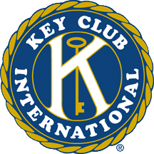

Key Club Projects Newsletter Volume 1, Issue 3 August 2007
In This Issue...

Introduction pg.1

Meet the International Board pg.1
Freshman Mentor pg.2
City Clean-Up pg.2
Back to School Picnic pg.2
Little Fundraising Drops pg.3

Hello everyone!
August is finally here and that means only one more
month of sitting by the pool, staying up until the wee hours of the morning, and hanging out downtown with friends. But the start of school also signifies the start of Key Club again. So, get on your feet, get up and make those projects happen!

Celia Zhang
269-470-0848 (Cell)
269-983-5668 (Home)
mikcprojectschair@yahoo.com

President—Grant Lin, Indiana District
Vice President—Joe Schibi, Alabama District
Trustees:
Kia Albertson-Rodgers, New York District
Sara Bolander, Kansas District
Chuck Black, Pennsylvania District
Nicole Bohannon, Alabama District
Joe Hartsoe, Illinois-Easter Iowa District

Trustees Continued:
Sydney Jiang, Indiana District
Katie Lewandowski, Pacific Northwest District
Caroline Noland, Carolinas District
Hannah Rowell, New England District
Joey Russo, Florida District
Nakita Sekhon, Pacific Northwest District

Meet our new International Board
The Key Club International Board is elected at International Convention consists of a president, vice-president, and 11 trustees and oversees Key Club International as a whole and makes sure everything is working properly.

Quote
“By finding peace within our own soul, we help make this world a less cruel place.”
--Unknown



Freshman Mentor

So remember those days
when you were a freshman
and to survive you had to hide in order to avoid being harassed by the big kids?

Help the new freshmen out by having an ice-cream social for them after everyone receives their schedules but before school starts. At the social, pair each freshman with a Key Clubber, and have the Key Clubber show the freshman around the school and their new classes. Tell the freshman a little about the high school, where their lockers will be, and what sports/clubs they can participate in. (hmmm..*cough cough*…how about Key Club?) Also answer any question the freshman may have about the high school. Make them feel comfortable and welcome.
City Clean-up

While it’s still warm, pair up
with Key Clubbers from
surrounding area clubs and
have a city-wide clean up.
Give each club a specific part of the city, and help your city by picking up litter, cleaning monuments, planting flowers, painting over graffiti walls, and redrawing faded parking lines. As a treat, meet together at a local restaurant/pizza place for lunch, and see if the restaurant is willing to give you a discount or donate the food. This project serves only to make your city into a better place, but also as a social event to get to now other Key Clubbers from around your area.

Key Club Back-to-School Picnic

Get back into the swing of Key Club by having a picnic for both old and new prospective members! This is a great time to catch up with each other on the happenings of summer and meet new members. It may also be a good idea to invite your K-family along as well, including your local Kiwanis club and Circle K chapters.

Call members ahead of time to schedule a time and place for the picnic, which will probably work best just after the start of school when students are not too burdened by loads of schoolwork.

To help defray the cost of food, work with your local Kiwanis Club to see if they are willing to help sponsor you. If not, you can charge each picnic attendant a small entry fee, but try to keep this as low as possible so that more people will be motivated to come.

In addition to serving our own food, also ask guests to bring a dish if they wish to help further defray the cost of food. For entertainment, see if a local rock band will be willing to play for the picnic a discount cost. You may also wish to have some speakers there to talk about Key Club and the benefits of volunteering. This would be a good time to introduce some of the projects your Key Club is planning on doing throughout the year.

Advertise for this event by speaking on the school announcements, putting up flyers in school, and sending out Facebook invitations. Emphasize that members ought to invite other friends in order to promote Key Club.

Most of all, have fun! This is a great project that lets you socialize with both old and new Key Clubbers as well as recruit new members at the start of a new school year!
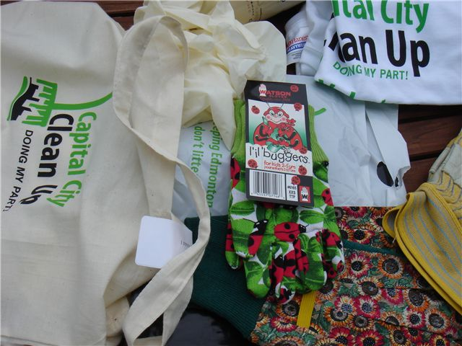
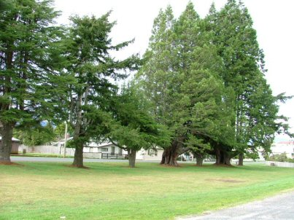
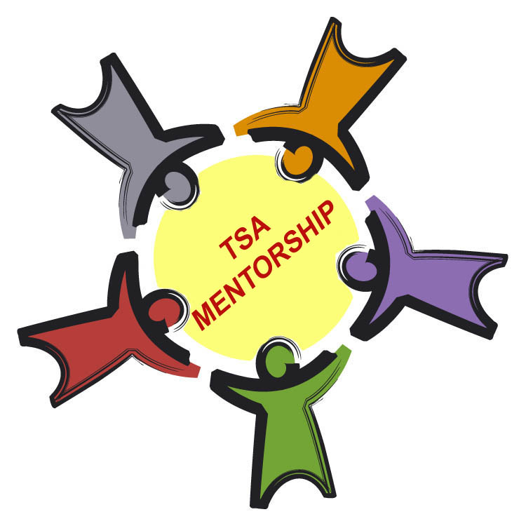
Little Fundraising Drops

The following is a list of wacky fundraisers, different from the traditional car wash and bake sale, but profitable nonetheless.
Money Tree

Who says money doesn’t grow
on trees? Give a new twist to the
old saying by participating in this
fundraiser. Make a cardboard tree and set it up at a sports game or school event, and tape envelopes on it. Inside the envelopes include notes, stickers, money (anywhere from a penny to over ten dollars), letters, or other miscellaneous things. Make sure, though, that each envelope contain s different things. A paying customer/supporter can buy an envelope off the money tree, and they win what is inside. (But don’t let them feel the envelopes before they buy it!)

Usually successful at big school events, this fundraiser arouses curiosity, thus encouraging more people to buy the envelopes and support you club/cause.

ction Again

Portraits With Animals

Kids love to be around
animals, so have an animal
photography session! Bring
in friendly animals from the Humane Society and have a photo booth at a local event. Set up a tri-pod and digital camera, and work out lighting ahead of time. Take pictures of kids posing with the animals, and have order forms ready so that parents can order reprints. Set a specific charge for reprints (Make them reasonable; $1 for a 4x6 is usually a good price), and offer to do other services with the pictures, such as turning them into a slideshow.

Advertise, advertise, advertise! The more people that know about it, the more will show up, and the more order you will get.

At the same time, encourage your guests to adopt the animals in need of a home! Ask your Humane Society to bring the proper papers and forms.



Reverse Raffle

Reverse the concept of the usual raffle
where everyone hopes to win. Give
each attendee of a local school event a “free” raffle ticket, and they can sell off their ticket to be excluded from the drawing for anywhere from $1-$10, depending on the situation.

But why sell off their ticket? Be creative with the raffle prizes: the winner can be pied in the face, or forced to do the chicken dance, or wear a clown costume with face paint, or…the possibilities are endless!


Hat Day

Talk to your school administrators
About the idea of a hat day.
Have students pay $1 to wear a hat for that day, and make it a race between the classes. The winning class gets total bragging rights! Other prizes could include ice-cream sandwiches at lunch (talk to food store to see if they’re willing to donate or give a discount), or being let out of school a few minutes early that day.

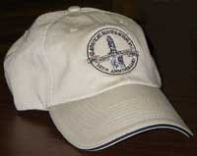

D

That wraps up the August newsletter—I’ll see you all again in September, and if you ever need anything or have any questions, please don’t hesitate to contact me!!

