Splash!

Hello everyone!
Reddish yellow leaves, cool breezes, late sunrise hours—without question fall has loomed across us. But as the weather cools our hearts still stay warm. Try out these new projects!

Celia Zhang
269-470-0848 (Cell)
269-983-5668 (Home)
mikcprojectschair@yahoo.com

ction Again
Key Club Projects Newsletter Express Volume 1, Issue 6 Fall 2007



Caring…Pass It On

Caring…Pass it On is a unique simple project that spreads goodwill across the community. The basic gist of this project is that each Key club member will receive several cards like one that I have outlined below. They are then to do a kind deed for someone, whether it’s buying lunch for them or driving them to school or leaving flowers at their doorstep. Upon performing the kind deed, hand them the card, and they are then to do a kind deed for someone else. Your club can either do this project year-round, or at the end of a two-week period or month, put an announcement in your school news asking any student still in procession of a card to return them to the main office.

Building Makeover

If there is an extremely physically
run-down community building
near where you live, offer to give
the landscape—and I don’t know
how else to put this—a makeover.☺
Offer to plant the surrounding area with bushes, trees, and flowers, repaint or decorate the building inside and out, place stepping stones to the sidewalk, or add a waterfall or bird bath where necessary. Other ideas include placing picnic benches outside the building and repainting parking lines. The sky’s the limit, and each building “makeover” will be different from the next!

Key Club Week
Key Club Week is the first full week of November that emphasizes the celebration of Key Club. Each day of the week will consist of a different theme to help show your Key Club spirit. I have attached Michigan’s international trustee Kia’s lovely newsletter that further describes in detail each day in Key Club Week.

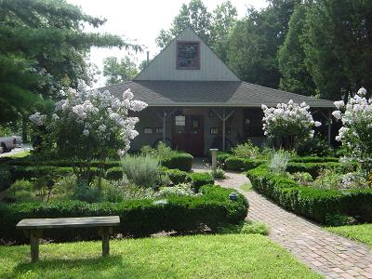

Michigan District Project!
As many of you already know, the Michigan district project for 2007-2008 is Alex’s Lemonade Stand. One of my jobs as projects chair is to pick a 2008-2009 district project. So if there is any organization that you feel would be a good candidate for the 2008-2009 district project, feel free to contact me!!

Also, if your club does projects that you would like to share with other clubs around Michigan, please please please send those to me, and I will include them in my newsletter or website, www.mikcprojects.org, giving credit to your club, of course. ☺

D

Trick-Or-Treat For UNICEF!

By now your clubs should have
received orange UNICEF boxes.
If your club would like more of those boxes, you may order them by calling 1-800-KIWANIS, ext.411


