Splash!

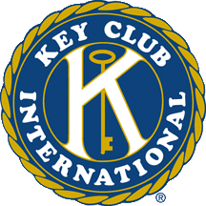
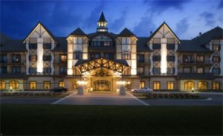
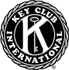

DCON DCON DCON DCON DCON DCON DCON DCON DCON DCON
That’s right…The district Board wants YOU to come to DCON, or district convention. This year’s district convention will take place in Boyne, Michigan from April 10th through the 12th. Many great events have already been planned, such as a spirit rally, a Kids Agains Hunger Packaging session, and officer training forums. Be sure to bring some extra money for the board auction and miracle minute fundraiser, and in your free time, check out the arcade and free water park.
The cost is $195, and the registration due date is March 7th. The convention
may take place in Michigan, but the district board promises that by the end
of the weekend, you will have gone “Key Clubbing Around The World”.

Attention All Key Club Members!

Key Club Projects Newsletter Volume 1, Issue 7 November 2007
In This Issue...

Attention All Key Clubbers…..…...p. 1
Read and Read…...…………..…...p. 2
Free Rice…….………………..…..p. 2
Legos……………..………….……p. 2
Your Ad Here…………..……..…..p. 3
Cheers……………...…….…...…..p. 3

Hello everyone!
I hope you all have gotten off to a good start in the new year and have survived the gruesome torture of exams—I know I certainly have! The start of the new year brings one major thing to mind—DCON 2007. In between new projects and fundraisers, make sure to get those registration forms in!

Celia Zhang
269-470-0848 (Cell)
269-983-5668 (Home)
mikcprojectschair@yahoo.com

Quote
“When you stumble make it a part of the dance.” --Unknown

Read And Lead!

The Key Club International winter a season of service is Read and Lead. Read and lead is a program where high schoolers read to younger students in order to foster a love for reading at a young age. To start one in your club, contact a local elementary school teacher or a church pastor to set up a time on a weekly basis to read to children.

Some tips:
Before you start the program, ask the children’s librarian for a list of the most popular books for children.

Be enthusiastic. Remember, the kids see you as a role model, so your attitude has a direct effect on them.

Speak slowly and clearly

Upon finishing the book, talk to your reading partners about the plot, characters, and lessons learned.

Obey all rules at the school or church you are reading at.

Record every book that you read with our buddy in a journal to show your achievements over time. Perhaps you may also want to tie a knot on a piece of string every time you finish a book. Every couple of sessions, have your buddy try to name the book that each knot stands for.

If possible, ask your buddy to read to you.

Why Read and Lead?
Adapted from www.readandlead.org

For children to:
~Improve self image from the approval of the mentor and the acquisition of new reading skills
~Improve attitudes towards learning
~Have positive role model
~Learn communication skills
~Receive diversity training

For Key Clubbers to:
~Learn leadership skills
~Learn teaching skills
~Gain empathy for others
~Learn responsibility that accompanies being a role model

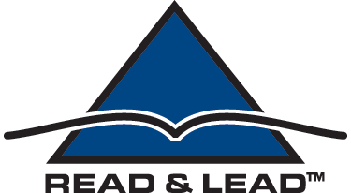


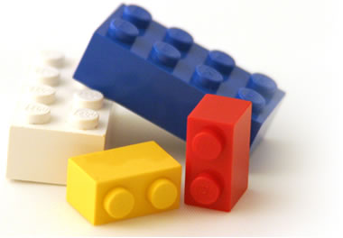
Your Ad Here

Well not here in this newsletter exactly, but in the District Convention program. To help cover the cost of printing district convention programs, we are asking clubs and companies to place ads, which can be from 1/8 of a page to a full page, in the programs. For more information, contact Greg Smith at smith5825@wowway.com
A Few More Project Drops

ction Again

Hey Michigan…
Hey WHAT?

Individual project for DCON

Last weekend, the district board met in Boyne and talked about convention details. It was decided that during the meet and greet, there would be a cheer-off between three groups of attendants. Not only will you be able to make up your own cheers, you will also be able to scream—what else than the Michigan Key Club cheers—on top of your lungs. So, as an individual project for DCON, memorize the following cheers!

M-I Pump It Up, Pump I
M-I
PUMP IT UP PUMP IT UP!
C-H-I
SHAKE THAT THANG!
G-A-N
WHAT'S THAT SPELL?
MICHIGAN!
HEY HEY, WE'RE MICHIGAN!
Hey Michigan?
HEY WHAT?
Hey Michigan?
HEY WHAT?
Show us how you shake that thang!
This is how we shake that thang!
BOOM shoo wala wala
BOOM shoo bang bang
BOOM shoo wala wala
THIS IS HOW WE SHAKE THAT THANG!
The P is for PARTY
And the A is for All NIGHT
The R is for ROWDY
And the T is for TONIGHT!
The Y is for YOU
And YOU know what to do so
PARRTYYYYYYYYYYYYYYYY!
Don't let your mama know
PARTTTTTTTTYYYYYYYYY!
Or she won't let you go!
PARRTYYYYYYYYYYYYYYYY!
Don't let your daddy know
PARTTTTTTTTYYYYYYYYY!
Or he won't let you go!
AIN'T NO PARTY LIKE A MICHIGAN PARTY
CAUSE A MICHIGAN PARTY DON'T STOP!

Michigan Cadence

Leader: I don’t know what I’ve been told,
Everyone: I don’t know what I’ve been told,
Leader: Michigan Key is mighty bold
Everyone: Michigan Key is mighty bold
Leader: When you hear our mighty call
Everyone: When you hear our mighty call
Leader: We’re the loudest of them all
Everyone: We’re the loudest of them all
Leader: Michigan
Everyone: Michigan
Leader: Key Club
Everyone: Key Club
Michigan Key Club…oh yeah!


Key Club…Caring, Leadership, Service, Character Building

