Splash!

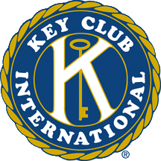

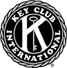

If your club hasn’t already turned in officer contact information, please do so as soon as possible, and send to our wonderful Michigan District Secretary, Chris Ding at michdistrictsecretary @yahoo.com. This info will be included in the addendum which includes information that supplements the district directory which your club should have received in October.

A humongous water park. A weekend at a beautiful resort in northern Michigan. A time to hang out with friends as well as meet Key Clubbers from all around the state. What does that make you think of? District Convention, of course! The 57th annual Michigan District Convention will be held in Boyne City, Michigan, on April 11-13. By now, your club should have
already received a registration preview that lists the cost for each person
attending convention. More detail, plus a Public Relations video to help your
club publicize the event, will also be mailed out shortly. But no matter what,
one thing is guaranteed: it will be a weekend you will never forget.

Attention All Key Club Members!

Key Club Projects Newsletter Volume 1, Issue 7 November 2007
In This Issue...

Attention All Key Clubbers…..…...p. 1
Reilly……………..…………..…...p. 2
Free Rice…….………………..…..p. 2
More Key Clubbers………….……p. 2
Alex’s Lemonade Stand..……..…..p. 3
A Little About Myself…….…...…..p. 3

Hello everyone!
November brings the thought of huge Thanksgiving dinners, with so many food choices it’s impossible to decide. You spot Grandma’s famous mash potatoes, and your aunt’s delicious stuffing, and your mouth starts to water. Across the table sits friends and family—a priceless yearly gathering. But remember, not everyone is as fortunate. Make the most of this season of giving by continuing your services to your schools, divisions, and communities. Remember that caring is our Key Club way of life!

Celia Zhang
269-470-0848 (Cell)
269-983-5668 (Home)
mikcprojectschair@yahoo.com

Quote
A preoccupation with the future not only prevents us from seeing the present as it is but often prompts us to rearrange the past. --Eric Hoffer


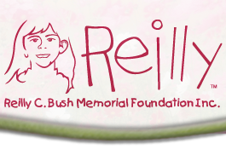
Project Spotlight: The Reilly C. Bush Foundation

In select newsletters from now on, I will try to feature one spotlight project for the month. These projects will consist of potential 2008-2009 district projects that I have looked at but have eliminated. Still, these spotlight organizations are great charities that I would highly recommend you club to participate in. This month’s feature is the Reilly C. Bush Foundation.
*Information taken from http://www.reillycbushfoundation.org/

The mission of the Reilly Foundation is to provide emotional, education, and financial support to chronically ill, critically ill, and economically underprivileged children while teaching children civic responsibility. In other words, the Reilly Foundation provides care packages that consist of an American Girl Doll, handmade doll nightgown, a pink Reilly Robe, “Stupendous” wristband, and a letter of encouragement for children in area hospitals around Chicago. Additionally, the Reilly Foundation also provides scholarships for underprivileged children to participate in extra-curricular activities, be it karate lessons, dance classes, or athletic events.

Your club can help out the organization by:

Nominating a child for the extracurricular scholarship program. If you know of a child ages 4-12 who could benefit from such scholarship, please fill out the attached nomination form and send to contact@reillycbushfoundation.org

Set up a dedication wall in one of your school’s halls. Print off copies of the Reilly Logo and sell to students at lunches and at sports games, usually for the price of one dollar. Put the donor’s name on the paper logo, and fundraise until the entire school hallway is filled with the names of kind givers.

Hold A THONATHON
Take any department, such as the music department, and ask them to play instruments for a half or entire day in dedication to musical scholarships for children. An English department can read and write all day for learning scholarships, and the athletic department could play a tournament all day to raise money for sports scholarships.

Sell or give out Reilly’s pink Stupendous bracelets. (Email at contact@reillycbushfoundation.org to purchase them). This is a wonderful way of conveying the organization’s message—to live a stupendous life—to live life to the fullest.

Another way to spread Reilly’s message is to print off little cards of inspirational sayings about living life in the moment. Pass these cards out to students just arriving to school, during lunch, and at public events.

A Few More Project Drops

ction Again

More Key Clubbers=
More Service
We have all heard of
that simple equation, right? But how exactly do we get more members? Besides the regular school announcements and flyers, I came across another neat idea at the KC board meeting this past weekend. On a specific day, put sticks of gum in students’ lockers. Tape on the wrapper information about your Key Club, and why students should join. You may also want to include a witty saying, such as
“No Matter Where You are, the Key Always Sticks” to grab the attention of students.
Free Food

This project can be
accomplished without ever
getting off the computer.
As many of you may
already know from
Facebook, www.freerice.com
is donating ten grains of rice
to the United Nations for every vocabulary question you answer correctly. So, take a few minutes (or a few hours) out of your busy day to both improve your vocabulary and donate to the hungry. Or skip your lunch period and go to the media center to play. Or have a party, invite some friends over, and race to see and see who can donate the most rice. the most rice. Be creative most r creative. Remember, the sky is the limit! sky is the limit!

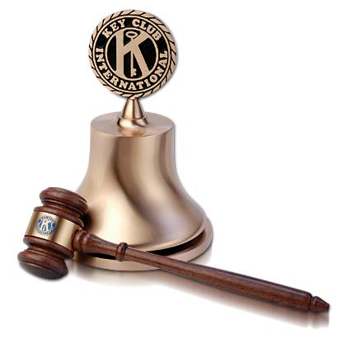





Alex’s Lemonade Stand
For Winter

As we all know, lemonade
and wintertime does not go
together too well. At least
not as well as lemonade to
cool off in a hot summer day. So, if your club is still looking to participate in the district project, try selling hot chocolate and/or coffee at public events in addition to lemonade. Again, all the proceeds from both the lemonade and hot chocolate should go to Alex’s Lemonade Stand.
A Little More About Your Projects Chair

Family: Only child…gets lonely at times
Favorite Subject: Physics.
Favorite Movie: Erin Brockovich
Favorite Book: Snow Falling on Cedars andTo Kill A Mockingbird
On thing I wish I could do: To
sing. When I was younger, I was
obsessed with American Idol, and dreamed of myself singing and dancing on that brilliant stage and being crowned idol. Today, I still sing, but for fun, whether it be when I’m doing homework or when I’m in the car.





