

Project
Ideas

For the Community

Every Child A Swimmer

E.C.A.S. is the acronym for Each Child A Swimmer, and is a program that helps incorporate swimming lessons in the P.E program at every elementary school. If your school system does not already have this program, lobby your school board to implement one. Statistics show that 80% of all drowning deaths happen within six feet of safety. Help decrease that daunting statistic by helping your school system teach kids to swim.

City-Wide Clean Up

Get together with other clubs from around your area and have a city-wide clean-up. Pick up litter, offer to clean monuments, and paint over graffiti on buildings. Afterwards, meet at a local restaurant for lunch.

Tips: It’s probably best to divide the city up so clubs won’t overlap each other. Also, assign different groups to complete different tasks, such as a group to paint, a group to clean up…etc. Each group should select a leader/captain to make sure the job gets done.

Twist: If your town’s parking lines are wearing out, offer to repaint them. This could also be done with basketball/tennis court lines at your school or a local park.

Ronald McDonald House

The Ronald McDonald House is a “home away from home” for families of sick children to stay at while the children are hospitalized for diseases. They charge families of victims a mere $10 a night, while the actual costs of actually operating it each night soar to over $100. If there is a Ronald McDonald House in your area (the four in Michigan are in Grand Rapids, Lansing, Flint, and Ann Arbor). Help out by:

~Becoming an office volunteer by answering the phone, guiding tours, and answering questions from parents.
~Planting flowers in the courtyard to make the house landscape look beautiful.
~Fundraise for Ronald McDonald House by selling and buying merchandise, as well as donating food, supplies, and toys.
~Speaking to others about Ronald McDonald House and what it does.
~Cooking a meal the residents. Set up a time with your Ronald McDonald House, organize members and buy food ahead of time, and assign specific jobs to each member, such as who is in charge of washing vegetables, chopping lettuce, preparing dessert, and cleaning up.

For the Community

Earth Day

Sponsor an Earth Day at your school to teach other students about preserving the environment. Hold a picnic, and invite your entire community to come. (You may want to charge a basic fee for food, or have each attendee to add his or her own dish). Ask local environmentalists, electricians, and people from the water and power department to come speak at your picnic. Also hand out different brochures and flyers about the environment and how our carelessness about earth is causing devastating consequences, such as the ruin of natural habitat for animals, global warming, and the diminishing of natural beauty.

To keep kids entertained hand out balls painted with earth, crossword puzzles about the environment, and lessons about the water cycle, and an interactive activity booklet. Visit http://www.epa.gov/region5/publications/happy/happy.pdf to print a full 12-page informational booklet for kids.

Other activities at your picnic should include a can recycling center where attendants can drop off their pop cans, (But don’t forget to take off the pop tabs!), a printer cartridge drive, a clean up campaign around the picnic area, and time put aside to plant trees and flowers.

In addition to the picnic, help out the environment by:

~Stopping junk mail. Not only are they annoying and bothersome, they also waste tons of paper. To reduce up to 75% of the junk mail in your home, write to:

Mail Preference Service, Direct Marketing Association
11 West 42nd St., PO Box 3861,
New York, NY 10163-3861

~Printing on both sides of the paper.
~Use fluorescent lighting, which only uses 20% of the energy a regular light bulb does.
~Using rechargeable batteries.
~Proofread all your papers on the computer before you print them to avoid double copies for a few mistakes.
~Carpooling, especially for long distances.
~Use glass cups and plates for regular occasions, instead of disposable ones.
~Recycling all your past school year papers.

For the Community

Food Drive

Place boxes in each classroom and ask students to donate food and make this a competition between classes.

Tips: Use empathy to get donations. Strike into the students’ hearts about how their donation will help feed the hungry. Show a video, tell a story, or describe a situation to make them want to donate food. And make the competition intense to get the students excited. For example, if the food drive becomes a yearly thing, make it a goal to beat the previous year’s record. Last year, one class in my school brought in 10,000 items, because they were so focused on beating the previous year’s record of 7000 for an Alternative Ed food drive. And at the end of that drive, students stacked the food into a tower fortress full of canned foods and Ramen, and it was neat to walk through it and see all that students could give.

Twist: You can “drive” for more than just books. Other great drives include a clothes drive for Salvation Army, a book drive to donate to the local library, and a school supplies drives for poor students.

Kids Against Hunger

Kids Against Hunger is was first started in 1999 by Richard Proudfit after he went on a mission trip to Honduras and witnessed the devastating sight of malnourished children. Serving as a wake-up call, the mission trip made him realize that he could make a difference, and began to invest his financial resources and personal energy into helping children. He thus developed a special food package that combined essential nutrients such as nine amino acids and crucial vitamins to taste and convenience. Consisting of rice, soy, meat, and vegetables, Kids Against Hunger has produced over 20 million meals and have aided countless children.

Your school can set up your own Kids Against Hunger packaging session. The best way is make a specific fundraising goal, and your club can package four times as much in food as the money you raise. Contact Don Burwell, director of Kids Against Hunger at 313-510-7156 for additional details and to set up a packaging time. Also, there will be a Kids Against Hunger Packaging session on November 10th, 2007 in Lansing, MI. Because this is a K-Family event, partner up with your local Kiwanis, Builders, or even K-Kids Club and drive together to Lansing for any of the five shifts. For more information on the packaging session in Lansing and to sign up for a shift, contact any of any of the following Kiwanians: Dave Siegrist at 734 453 7106, Terry Strickler at 517 282 9653, or Bill Fullmer at 517 669 9720. Donations for the Lansing packaging are encouraged, but not required. This will be a fun opportunity not only to help out with the cause, but also to meet and make friends with many new people!

For Teachers

Without question, teachers are imperative to the world and our lives. They share with us their knowledge and help educate the future leaders of tomorrow. Without them, we would not be. So thank them for their unrelenting dedication with the following:

Project Paint

Are the faculty bathrooms or the teachers’ lounges at your school plain and bland? Spice it up by decorating them with wallpaper, paint, inspirational quotes, and pictures.

Tips: Plan the date for this project ahead of time, and make sure that it doesn’t conflict with any big event at your school, so that there is a bigger chance of having more volunteers help out. It may be fun to do it when teachers are not in school so that when they come back to work, they will be pleasantly surprised.

Set a specific budget for supplies, so you don’t go overboard when you go shopping for them. Try to buy just the primary colors of paint; that way, you can mix colors to created endless new ones if needed. Talk to your local hardware store and tell them about your project, and they may want to give you a discount on the supplies, especially if you promise to put their logo on the wall.

Teachers Appreciation Breakfast

Hold a breakfast for teachers during teacher’s appreciation week. Ask for student volunteers ahead of time and send out invites one week in advance. See sample invitation in the appendix, pg. 47.

A buffet style breakfast works best for this. Menu: hash browns, eggs, biscuit sandwiches, French toast, and pancakes. If your budget allows, include fruit, croissants, and muffins as well.

If your school normally starts at eight, have students arrive at 6am and invite teachers to breakfast at 7am. It may be a good idea to mix the pancake batter and cut the sandwich meat beforehand so that you don’t have to rush to get breakfast done in the morning.

This could be an eat-in or take-out kind of breakfast. If it is a dine-in breakfast, decorate the cafeteria with thank-you and appreciation banners. During breakfast, have students speak about why they are thankful, or what the teachers have
taught them, or about their favorite memory inside the classroom.

For Teachers

Walk of Fame

Turn your school into a Hollywood red carpet event for teachers. Line the main entry hallway with a piece of red carpet, and put gold stars with a teacher’s name on each one. It may be fun to also get the teachers’ handprints ahead of time (but don’t tell them why!) and place the prints beside their star. Have students, parents, and volunteers from the community cheer for the teachers as they enter the school that morning. Take pictures and publish on the announcements and in the newspaper.

Tips: See if anyone is able to donate the red carpet, and if not, ask your local hardware stores if they have scrap or leftover pieces they are willing to sell to you at discount prices. Make the stars and trace the teacher handprints at weekly meetings, and lay the carpet late in the evening the day before or early morning the day of.

Teacher of the Week

Ask your local newspaper to dedicate a special section each week to a teacher in the area who has gone above and beyond their call of duty. Anyone can nominate the teacher and in the featured article, include a picture, information about the teacher, and what they have done to exceed usual expectations. If possible, work with your newspaper to reward the winning teachers with luxury gift certificates. Their deeds can impact just one student, or they can impact an entire community—either way, they should be honored. Put the nomination form in every local school office, and upload it onto the newspaper and school website as well.

FestScript

At the end of the school year, give each teacher a personalized binder that shows the year in review. Include in them writing samples from each student, pictures taken of the teacher from different events, and letters and comments from parents and the community about how the teacher has impacted their kids’ lives. This will surely leave an everlasting impression of the past school year.

Tips: Throughout the year, take picture of teachers at work, helping students, grading papers…etc so that you have the proper materials at the end of the year. Also, as the year moves along, have students record kind things teachers have done to help them. Did they bring treats for you at an after school event? Maybe stayed after school to help you with an assignment or to edit countless English papers? Did they or help you work out a scheduling problem? Record anything and everything that can potentially go into the binders!

For Teachers

Appreciation Quilt

Have each Key Clubber draw a design dedicated to a specific teacher on a quilt square (include every teacher), and sew those squares together to form a patchwork quilt. Present the quilt at a school assembly or gathering, and hang it in the halls as a reminder of all your appreciation for teachers. If you do not have a really big school, you may want to make one every year or add squares as new teachers come and old ones go.

Tips: Emphasize to Key Clubbers that no sewing skills are necessary for the quilt designs. Then, ask your sewing class to sew all the designs together and put a back to the quilt after all the designs are finished. If there are not too many teachers at your school, you may want to add a border showing off your school colors and activities.

Appreciation Letters

At the beginning of a specific week, ask your fellow students to write a personal appreciation letter to any faculty member that they choose and drop it off in a box in the cafeteria or office. At the end of the week, get together the Key Club and sort out all the letters and deliver into each teacher’s mailbox. (Make sure that every teacher gets one, though). This project will garner immense response from the teachers because it is the students they impact the most, and when they receive the appreciation back, it’s priceless.

Adopt-A-Teacher

Make one day (during teacher’s appreciation week is a good idea) Adopt-A-Teacher day. Assign each Key Clubber to a specific staff member, and the student has the responsibility to help the teacher throughout the day by helping grade papers, running errands, cleaning the classroom, sorting out homework, or delivering messages. Take photos of teachers with their student helpers…they would be great for the yearbook!

Car Wash!

Treat teachers to a free car wash on teacher’s workdays or half days. To minimize costs, have students bring buckets, soap, and old towels from home. Be sure to take lots of pictures both for promotion of your club and the yearbook!

Adopt-A-What?

With a creative mind, you can almost put anything in place of the word “what?” in this project. Below are a few suggestions, though your club is certainly not limited to these.

Adopt-A-Family

As the holiday season rolls around, there are many working families who earn below-average income that do not have the money for the usual holiday luxuries. As a club, you can help these families out by purchasing presents for them.

Tips: Fundraise for this event by placing jars in every classroom and asking students/teachers to donate their spare change, and like always, be sure to tell them about where their donations will be going towards. Set a fundraising goal, when to have the goal achieved by, and reward the winning classrooms—when we did this in the math department, the winning class was treated to a pie day on March 14th.

Ask your chosen families for wish lists—what do they hope to receive for the holidays? After all the money is collected, ask for club volunteers who are willing to shop for the presents—it works best if each person shops for the wants of a few specific family members.

Make one club meeting a present wrapping day! Invite anyone to come help wrap presents, even if they are not in Key Club. (This should also help promote your club membership). If possible, publish pictures in your school website, video announcements, and newspaper, and correspond regularly with your adopted family.

Adopt-A-Turkey

This year, instead of feasting on roasted turkey, advocate to save a turkey from their fate of ending up on the dinner table.

Adopt-A-Highway

Find a beach, street, or highway that has been littered upon, clean it up, and make it beautiful. Go back regularly to see that the highway remains that way. Maybe you’ll want to plant flowers or trees at the sides of the highway to make the scenery of a once abandoned place a more pleasant one.

Adopt-A-What?

Adopt-A-Soldier

This project is actually called Foster-A-Soldier, but it was so similar to Adopt-A-Family that I decided to put it into this category. Through this program, your club can choose a soldier to support by their branch of service, their location, birthday, home state, or have the program automatically pick a deserving soldier. Upon your selection, you will receive information about your soldier, such as their interests and likes/dislikes, and as a club shop for a care package according to the soldier’s needs. By participating in this project as a club, you will be able to immensely touch a person’s life and show that you care. An excerpt from its website https://www.treatsfortroops.com/foster/index.php:

“Hello and thank you so much for your box! i just got it today (Jan 4th) and I was when it arrived. we all love getting packages but yours was over the top! i love the burts beeswax gifts they are some of my favorite products! your an amazing person, someone God put on this Earth truely to inspire others!..thank you so much for your time and heart! thank you and your in my prayers! Happy New year ”
–Thomas, U. S. Navy

Adopt-A-Grandparent

Find an elderly person from your local nursing home that you can provide company to and visit him or her on a regular basis.

Tips: Before you adopt a grandparent, ask the front desk of your local nursing home to ask about details, such as if there is training involved, what you can/cannot do, if there is a time limit, and what to bring to visits.

Before your first visit, think of a list of topics that you could talk about so that when the time comes, your visit would not be awkward. Potential topics include introducing yourself, what school you go to, and what activities you are involved in. Also ask the senior to introduce themselves to you: how life was like when they were growing up, what they did before retirement, what their interests are…etc. Be open to conversation topics; some of the things the seniors say may seem confusing or archaic to you, but still listen politely.

Many senior citizens are lonely and will enjoy your companionship. But remember that every senior is different. While some may just want to listen to you, others will need you to listen. Be flexible.

Adopt-A-What?

Adopt-A-Freshman/Freshman Mentor

Help the freshmen adjust to high school! At the end of the previous school year, get shirts for everyone in Key Club that shows that you are a mentor. Wear these shirts on the first and second day of school so that freshmen know to approach you if they have any questions. Offer to help the freshmen find their way to class, show them how the lunch system works—basically, welcome them into the school. Don’t forget to introduce and persuade them to join Key Club!

Twist:
This twist usually works best if the Key Club is about the same size of the incoming freshmen class. If not, take volunteers outside of Key Club. A few days before school starts (after the freshmen have their schedules), hold an ice-cream social for freshmen. At the social, each freshman should be paired off with a Key Clubber. If there are not enough Key Clubbers, pair two freshmen per Key Clubber. The Key Clubber will show the freshman around the school, where each of their classes are (this is why it’s a good idea to hold this after schedules are handed out), where their lockers will be, how to get the most out of passing time, the importance of taking high school seriously, what clubs/sports they can join (Hmmmm…how about *cough cough* Key Club?), and any basic rules/traditions about the high school that you wish to inform them of. Also answer any questions and calm any uncertainties the freshman may have. Be there to help him/her again when school starts.

Expand by implementing this project for elementary kids going into middle school.

Adopt-A-Manatee

Help save manatees from danger in their environment by adopting a manatee. Don’t worry, you don’t have to live in a coastal area to do so. By adopting a manatee for $25, you’ll get a photo of your manatee, a biography on him or her, an official adoption certificate, a membership book, and four newsletters about manatees throughout the year. What’s also cool is that you get to read mini biographies and see pictures of manatees up for adoption and choose which you wish to adopt. Your money goals towards the following, adapted from http://www.savethemanatee.org/
~Fund manatee rescue, rehabilitation, and research efforts in the U.S. and the Wider Caribbean ~Support manatee education and public awareness projects ~Protect manatees and their habitat through advocacy and legal action

For Kids

Kids Safety Clinic
*Thanks to the Houghton Lake High School Key Club for the ideas listed in this project.

Hold a clinic for kids to teach them about safety and first aid. This is a huge undertaking and will require vast planning and lots of members and effort. But this project is a great way to promote your club and involve all Key Club and Kiwanis members and the whole community (and help complete the district goal!).

Possible topics for this clinic include teaching kids how to take care of a cut, the basics of CPR, what to do when they are hurt, the importance of exercise, nutrition, and healthy habits such as washing hands and getting yearly check-ups, the importance of abstinence from drugs and alcohol, how to call 9/11, what to do in case of an emergency, and different types of safety, such as water, bicycle, and electrical safety.

To make the clinic more interesting, have hands-on activities. At one station, have cotton balls and bandage rolls so that the kids can learn to wrap their arms or legs in case of a big cut. (And when they go home they can also tell their parents that they broke their arm and went to the hospital). In another station, show kids how much sugar there really is in Coke and candy and the importance to control intake of them. In another, fit kids into helmets and show them the importance of wearing reflective clothing when bike riding. Perhaps you may want include the community in this, and ask the police, firefighters, and the E.M.S to help. Each group could teach the kids about their respective fields. The firefighters, for example, can bring their fire truck and show the kids about the process of fighting fires. When I went to a camp like this, the firefighters also let us use the hydraulic pump so that we could feel the pressure of the water coming out of them. The police can bring K-9 units and show how the dogs are trained, what crimes they help solve, how they help out, and when they usually retire. The E.M.S could bring an ambulance and provide hands-on activities to kids to show them what really happens in the case of an emergency.

Because this is a community event, see if the newspaper will give you a discount on an advertising section, and have your local radio stations broadcast it before and after the event as well. See sample flyer in the Appendix, p. 48 that you can use to advertise.

To keep things from falling apart at the last minute, plan the event months ahead of time. Pick a day that doesn’t conflict with other events in town, and a day where the police, firefighters, and E.R.S will likely be available. Call the respective groups ahead of time to make arrangements, and be sure to send out thank-you notes afterwards.

For Kids

Kids Safety Clinic (Continued)

Serving food (such as a barbeque) will make this event a livelier one, and have a few carnival games and rent inflatable (if your budget allows). Initially, this project will cost quite a bit of money, so get a YOF! (See form included in the appendix, p. 66) Another way to raise money is to charge guests an entry fee to your clinic. If there is extra money after all costs are figured out, donate part of it to the fire/police/ambulance station to thank them for their efforts.

If this project is planned accordingly and advertised well, it could turn into a gigantic event that will promote your club, teach members leadership/planning skills, and fill you with pride for successfully making a difference.

After-School Tutoring

Hold an after-school tutoring event at your elementary schools on a regular basis. At the tutoring sessions, offer to not only help the kids with homework, but also teach them new things. It’s fun to make flashcards with multiplication/addition tables, geography, science facts, and vocabulary, and to play the memory game (Question and answer should be a pair) with the cards. If you find kids that are especially bright and eager to learn, teach them harder things they usually don’t learn in elementary school, such as basic algebra problems, or explaining what Chemistry really is. Also, if the students do not have homework, or have finished all their homework, read to the kids, or for fun, have them read to you. For more information on reading to kids, see Read and Lead, page 30.

Humane Society

Go to your local Humane Society and offer to feed and walk and play with the animals—they will surely love your attention and care. Also, help the Humane Society advertise and work to get homes for as many of the animals as possible. Work with the Humane Society about bringing a few of the animals to visit at your school, and invite all students, parents, and staff to see the animals. Encourage them to adopt, and bring the proper adoption forms if necessary.

Twist: Hold a clinic for kids to teach them about how to properly care for animals!

In addition to the above, help animals by:

--Report any abuse you see of animals to your local Humane Society immediately
--Buy products that are not tested on animals

For Kids

Humane Society (Continued)

--Put a bird feeder in your yard
--Purchase synthetic leather products
--Have a day each week or month where you will boycott meat

Geopals

Help kids learn about geography with traveling stuffed animals. You can do this project with an elementary classroom, a church group, kids you tutor, a group of at-risk kids, kids in hospitals…etc. Buy around five or six beanie babies for your designated group and little bags for each one. Inside the bag include writing utensils, a disposable camera, and a bit of money.

Each time someone in your community/school goes on vacation, ask them if they could take a geopal along. Encourage them to take pictures of the geopal in their respective vacation places with the disposable camera as well as write entries in the journals about the events each day or how the geopal’s vacation place is like. The money is to cover any costs that may arise for the tourist while with the geopal. After the geopal’s return, read the journal entries to the kids and show them pictures as well as explain to them a little bit about the background of each place. (This is where a little research might come in) Be sure to write thank whoever took the geopal along with them for vacation.

Babysitting

Offer parents free babysitting services—they will love you for it! Good times for this service would include during PTA meetings, school events, and around holiday season to take some of the chaos off the parents’ shoulders.

Tips: See if you can set up this project in a specific classroom at either the high school or elementary school. Then plan activity stations the kids could participate in. Set up a craft station, have a treasure search with clues, bring board games, have books to read (Read and Lead!), show a movie, and if an oven is available, make mini pizzas out of English McMuffins! To add extra excitement, have a raffle each hour and give away books. Be sure though, to reward even the kids that do not win with some little prizes.

If the babysitting is still during the daytime, take the kids outside to play on the playground, or have outdoor games such as three-legged races and Capture the Flag.

Music Oriented Projects

Benefit Concert

Ask your band, orchestras, drama team…etc to coalesce and have a benefit concert for any organization you choose. This is a great way to donate to the Key Club International Projects.

Tips: Plan how the concert is going to be organized. What will be the order of the show? Will the groups have to learn any new songs/pieces? Will they be playing together or performing in different acts? Who will host, or will there be a host? When will the concert start and end? How will the stage be set up? This is a huge project that requires a lot of planning, but if it is successful, it could raise a lot of money. You may want to turn this into a whole school event, not just for Key Club.

Set a price for admission and sell tickets before and after school, during lunch, and have individual members sell tickets as well. To encourage members to sell, reward each member who sells a designated amount with a free ticket to the concert. For sample tickets and flyers, reference Appendix, p. 49-51.

Twist: this could also be done with Battle of the Bands. Have high school bands in your area pay a fee to compete in this, and charge the audience for tickets as well. Of course, reward the winning band.

And remember: Advertise, advertise, advertise!

Performing Arts
Get together a group of students and perform for the senior citizens during holiday season. It doesn’t have to be anything fancy or complicated. When I participated in this project in sixth grade, many students sang Christmas chorals or played simple songs on the piano that they had learned in music. Afterwards, hand out home-made crafts and cards. From what I could tell, the seniors extremely enjoyed and appreciated our performance.

Shake Off Those Nerves

Nervous about Solo and Ensemble or an upcoming musical audition? Playing for seniors or patients in hospitals is a great way to loosen those nerves as well as getting good experience of playing in front of an audience. Also, organize elementary and middle school children to play for the respective groups. Not only will their performance be extremely appreciated, the kids will also be able to have a chance to gain valuable performing experience.

For your school

Multicultural Fair

Hold a multicultural fair at your school. Have students from different nationalities set up booths in your school library or cafeteria to show off culture in their respective areas. In the booths, include food sampling, books about the country, traditional clothes worn there, and the country flag. Hold this fair for an entire day, and invite teachers to take their classes to the fair each hour.

Tips: Make the fair funny! When we had this at our school, the Korean booth had food sampling that included a kind of traditional tiny fish that had a weird aftertaste. People willing to try the fish had their picture taken when they made funny faces about how bizarre the fish tasted. The funkiest pictures were published on the announcements for laughs. Fund this event by selling hot chocolate/coffee from different countries for a dollar a cup.

Sister Schools

To expand outside the realm of your town, become sister schools with a school across the U.S., or across the world. Write letters to each other regularly, and send students to visit every summer. When I was in middle school , our school district became friends with a New Jersey school that was directly affected by the 9/11 attacks. We helped them cope by sending letters, goodies, and a quilt for remembrance of all the heroes that died. A few select students got to visit the New Jersey school at the end of the school year.

Your sister schools can also be across the world. Midland, Michigan is sister schools with Handa, Japan, and each summer, the two schools send three students to visit the other and learn about culture half-way across the world.

Good Grades=Good Times

Encourage your peers to take their academic life seriously, and motivate them to get good grades. Make it a goal to improve the school average GPA by 0.5 points by the end of the school year. Invite anyone who improves their GPA by 0.5 points (or any number you choose) or more to attend an end-of-the-year pizza/donut/ice-cream party, in which they get to get out of class for.

Tips: Don’t forget to include the people with already high GPAs that cannot be improved by 0.5 points. Invite them to come to the end-of-year party as long as they maintain their GPA.

Twist: Also speak to your incoming freshman class about taking academics seriously. (See Appendix, p. 52)

For your school

Spicing Up Your School’s Walls

Are the walls in your school dull and bland? Ask your school principal if you could spice them up by gathering students over the summer to paint them with specific designs. In the wall leading to the auditorium, for example, paint a picture of a drama mask or a collage of musical instruments. In the language hall, paint phrases in different languages offered at your school. Use your imagination…the possibilities are endless.

To recruit more members for this project and to get them excited, pass out free shirts to everyone who attends. Or, as a twist, give everyone plain white t-shirts, and have a little tie-dying social before painting the school walls. Also provide iron-ons to put on the tie-dyed shirts, and have everyone sign each other’s shirts. (This was a great success when we did this at a district board meeting).

Twist: In one of the halls, instead of painting the walls, ask students to leave their hand-prints and write inspirational sayings on their “hands”. As old ones go and new students come, add their hands as well.

New Club Building

Help start a Builders in middle schools in your area! Talk to your local Kiwanis Clubs to see if they are willing to sponsor an additional middle school club. At the same time, visit your middle schools and speak to the kids (if you could do this at an all school assembly, it will be the most effective) about what Builders Club is, why they should join, and the rewards associated with joining…i.e. leadership, caring, a love for the community, a dedication to helping others.

Tips: For more information, check out www.buildersclub.org and click on New Club Building in the upper-left hand corner. There, you will find information about how to charter, and the paperwork involved. You will also be able to order two Builder’s New Club Building kit—the first that introduces information about Builder’s Club and the second that assists with the club building after your local Kiwanis Club has agreed to sponsor your middle school club.

You can do the same with K-Kids (www.kkids.org ). Also, try to start other Key Clubs in your area. Are there high schools around that do not have a Key Club? Maybe try to get one started in a private school? Tell these schools about Key Club..and how much you love it!☺

For the Homeless

700,000 people in America alone are homeless, and the mean age of a homeless person is only nine. If this daunting statistic consists only of America, imagine how many people in the world are homeless, hungry, and reside in poverty. Help them out, in addition to fundraising and donating, in the following ways:

~Volunteer your hobbies and interests to the homeless. Whether it’s drawing or singing or cooking, teach them to the homeless and share your passion.

~Cook for the homeless at the local soup kitchen. In most cases, your club can bring your own food and cook it at the kitchen, or you can cook food already stored in their pantry. Encourage as many members to come as possible—this is an easy level project that can get many people involved. Make sure to pick a good time to do this; volunteering to cook for the holidays is great, but also pick some normal mundane days to help out. (Many people volunteer to help cook during the holidays, but many soup kitchens have a shortage of volunteers during regular days).

~Donate toys to children in the homeless shelter. Because money is scarce, parents often spend it on necessities such as food and clothing, but not novelties like toys. Give these children a chance to entertain themselves and pass their time by donating toys for them.

~Take the children in a homeless shelter on a field trip they would otherwise be unable to afford. (Of course, this would allow adult supervision, so ask for parent volunteers as well). Trips could include to the zoo, an aquarium, the ice-skating rink, a kids museum, mini-golf, or a local fair. In each of the listed activities, ask the respective companies for ticket discounts and donations.

~Lobby for laws to help the plight of the homeless by writing letters to newspapers, contacting your senators and representative (write, call, and visit them), and write about the issue in school newspapers and newsletters.

~Purchase Street Sheet, a biweekly newspaper sold in nearly every big city in America, that helps the homeless earn money that is put aside for rent. Every issue of this newspaper sold will add five cents to the homeless person’s account for rent.

~Most of all, respect the homeless and treat each as an individual. Remember that every homeless person comes from a different background and ended up in their
plight differently. Some may have gone bankrupt from a once successful company,
while others may have abused substances or were abused themselves. Do not judge or think of stereotypes; instead, listen to their stories, give them your full attention, and talk to them with courtesy.

For Your Library

Spare Room

Ask your library if there is a spare room that you could turn into a kids reading room. In the room, put a variety of fun children’s books and decorate the walls with kids’ handprints. Include select toys and comfy reading chairs as well!

Twist: You can also put together a room just for teens that include popular books such as Chicken Soup For the Teenage Soul, Sisterhood of the Traveling Pants, the latest adventure series, teen magazines, and of course, Harry Potter books. Again, include comfy reading chairs as well as a table where teens can do homework if needed.

Reading Day

Hold a reading day at your local library (this could also be done usually in the summer) kids can come to the library to read all day. A rather relaxing day, kids can bring blankets, pillows, and snacks and read on the floor but remind the kids that they must read. Between hours, provide for the kids little activities, such as book talks, scavenger hunts, or a name game to help increase the fun. Log the number of hours the kids read to show how much reading truly matters.

Summer Reading Program

Encourage kids to participate in the Pizza Hut reading program. Also, if your library does not already have a summer reading program for kids, work with your librarians and see if you could get one started. Talk to local restaurants to see if they’re willing to donate coupons for prizes. (McDonalds, Wendy’s, Dairy Queen, and Kilwin’s will usually donate). Set a specific goal for kids to read to, such as 25 books or 200 pages. If they accomplish the goal, award them with not only the gift certificates, but also a chance to win a grand prize such as a bike or comfy chair. To help the kids achieve their goals, set up a reading time at the library each week to read to the kids, which should also count towards their goal.

If your local library does a summer reading program, invite them to come to your high school, middle school, and elementary schools to talk about the program as well as book talk the latest books to encourage reading over the summer.

For Your Library

Reading and Recording

Read children’s books out loud and record them on tape. This can be done with one person reading the entire story, or with several students, each reading one character’s dialogue. Donate these tapes to the local library, or to sick children so that they have something to pass the day by. This is an easy project that does not involve a lot of money, but could involve your whole club

Twist: If some Key Clubbers are fluent in a language besides English, ask them to record stories in their native language as well. Or, make up your own stories concerning themes such as courage, perseverance, determination, and belief.

Twist: In addition to recording the stories on tape, also work with your library to see if you could set up a hotline that children could call to listen to the stories. Include short bedtime stories as well.

Cultures, Cultures, Cultures!

To further learn about other cultures, feature a specific nationality at your library each month. (Work with librarians on this) Have a showcase in the main library room, and make posters, display books, and showcase traditional things associated with that culture. On the front desk, feature a “did you know…” trivia fact on there each day or week. Or, instead of simply saying the trivia, ask it in a question form, and allow guests to submit their answers in a box. Then sort out the answers and draw a winner from the pile of correct answers to reward.

Library clean-up

Visit your local library and help clean up and keep it clean. Assign different duties to each Key Clubber, such as shelving books, picking up, and putting out displays. Do this on a regular basis.

This ends Act One of project ideas; after the intermission, the District and International projects!

Key Club…Caring, Leadership, Character Building, Inclusiveness

District and International Projects

District Projects

As I mentioned before, it is one of the district board goals to have 90% of all Michigan club participate in at least one district or international project. It’s easy to participate, and the district board will love you forever for it! ☺

Alex’s Lemonade Stand

Alex’s Lemonade Stand, the 2007-2008 Michigan District Project, was created by four-year-old Alexandra Scott, who had a dream to help find a cure for childhood cancer. A victim of the disease herself, Alex set up the first Alex’s Lemonade Stand in her from front lawn with her brother in July 2000. Over the next few years, her cause evolved into a nationwide charity organization, and thousands of stands have been set up across the country to help raise money for her cause. Sadly, Alex passed away at the age of eight in 2004, when she had raised over one million dollars. However, her spirit and determination to fight cancer still lives on. Since her death, money raised for Alex’s Lemonade Stand has topped twelve million dollars. As a district, Michigan Key Club is helping her dream become reality by participating in her cause. Help out by:

--Run a lemonade stand and donate the proceeds to Alex’s cause. This can be done virtually anywhere—at school lunches, in your neighborhood, at youth groups/church events, at a mall, at a fair, on the beach, or a local sporting event. Make sure that you tell customers about Alex’s cause and exactly where their money will be going towards. You may want to have brochures and flyers at your stand that help further explain Alex’s Lemonade Stand childhood cancer. See Appendix, p. 53 for a sample flyer from www.alexslemonadestand.org

--Print out paper lemons and team up with local stores to sell them for $1 each. Also, encourage your community to purchase products from Alex’s Lemonade Stand gift shop online.

--Have an Alex’s Lemonade Stand birthday party. Instead of the usual lieu of gifts, ask your guests to donate any amount to Alex’s Lemonade Stand.

--Have a lemon-themed sale by selling all yellow things, or have a “Wear Yellow to School Day.”

--Make a donation in loving honor or memory to someone in your community who has had a struggle with cancer.

--Organize a 5K run or Walk-A-Thon.

District Projects

Alex’s Lemonade Stand (Continued)

--Have a food tasting event at your school, and be sure to include lemonade and lemon tasting as well!

--Host an Alex’s Coffee House and serve breakfast, coffee, and baked goods and desserts. Organize entertainment from the music and theater department, and ask students to promote all around. Be sure to set an appropriate admission fee, and put containers for donation.

--Visit your local elementary and middle schools to teach about cancer, its cause, and its consequences. In addition to speaking to the students, have them do several activities with Alex’s Lemonade Stand, including having a coloring contest using Alex’s pages (see appendix, pgs. 54-55), helping them make their own lemons and lemon cups out of paper and clay, and reading to them “Alex and the Amazing Lemonade Stand”.

Have members make “Alex’s Lemonade mini-stands”, which are paper boxes shaped like a lemonade stand, and place them in classrooms and ask students to donate. See appendix, pgs. 56-57 for instructions and the mini-stand template from Alex’s Lemonade Stand’s official website.

Hold an yellow-themed Easter Egg search in April and have all participating families pay a small fee to participate. Donate proceeds to “Alex’s Lemonade Stand.”

Publishing a newspaper article about Alex’s Lemonade Stand” to raise further awareness.

Governor’s Project—1/24

“Committing ourselves to experiencing, for one day, what they have for all of theirs."

1/24 was created by 2007-2008 Michigan District Governor Stephanie LaRue when she first read that one billion people, one sixth of the world’s population, live on less than one dollar a day, and decided to do something about it. In addition to the above, consider the following statistics*:

--The average American makes about $112 a day

--Every three seconds, a child dies from preventable diseases.
*As adapted from the 1/24 flyer and video.

District Projects

Governor’s Project—1/24 (Continued)

--100 million children miss out on school completely.

--It would cost $3.5 billion a year, less than the money Americans spend on ice-cream, for every child to go to school

--207.8 million people in Africa are malnourished

--At least twelve children have died in the time it took you to read this brief.

A main event for 1/24 is that every summer, students from all across Michigan will get together in a select city in Michigan and live off of one dollar for twenty-four hours. Before this event, they ask friends and family to help support the cause. This event helps increase awareness about the plight of the impoverished and help contain that poverty by raising money and experiencing for one day what it’s like to be in the shoes of the poor.

A typical 1/24 event starts at 8am and ends 8am the next day. Each attendant is allowed to bring $1 and white sheets, shirts, and markers to make 1/24 gear (Shirts, banners, headbands…etc). During the event are activities that teach students about how it’s like to live in poverty, such as shack making out of boxes, walking miles to the nearest store to spend the $1 on food, and other team building activities.

Schools can also set up their own 1/24 events by finding a specific time and location and inviting students (and don’t limit this to only Key Clubbers) to donate and participate. However, students are not limited to that event in order to participate in 1/24. Anything done to help combat poverty and hunger, such as helping the homeless (see for the homeless section, p. 22), spreading awareness, cooking a meal at a soup kitchen, having food and clothing drives…etc will count as participating in the governor’s project.

All proceeds of 1/24 will be donated to three organizations: UNICEF (see page 29), Action Against Hunger, and Invisible Children. For more information, visit
www.Myspace.com/1twentyfour, join the Facebook group 1/24, check out the 1/24 video at http://youtube.com/watch?v=8GA-dF7A4LQ. or email at 1twentyfour@gmail.com.

International Projects

The Key Club International Major Emphasis Program consists of four seasons of service, each designed specifically to help children: UNICEF for the fall, Read and Lead for the winter, March of Dimes for the spring, and Children’s Miracle Network for the summer. However, the seasons merely serve as guidelines, and your club does not have to strictly follow them. In addition to the above, there is a two-year service initiative, High Five For Health, which lets Key Clubbers provide hands on service to further help children.

UNICEF
Fall Seasons of Service

The fall season of service is UNICEF. Last year, the initiative was Kicking HIV/AIDs Out of Kenya, a program that used soccer to spread awareness and teach leadership among girls. After raising $660,000 for the initiative through trick-or-treating for UNICEF, there is now a new initiative: the Swazi Children Care Project.

Swaziland is a landlocked country in Africa where 42% of the adult population is stricken with HIV/AIDs. That means many of the country’s children are left orphaned: in fact, 21% of all households in Swaziland are headed by the children themselves, often with older siblings taking care of younger ones. Thus, all the money raised for this initiative will go towards care points across Swaziland that will provide a haven for children to stay at during the day. Moreover, the care points will give children free meals and allow them to interact with other kids and adults.

The fundraising goal for the Swazi Children Care Project is two million dollars. So get out there, with your friends, your school, and your community, and help raise money for The Swazi Children Care Project!

*When it comes to trick-or-treating for UNICEF, it may be fun to team up with a rival school and have a competition to see which school raises more money. Also, several weeks before Halloween, place the orange UNICEF boxes (included in this year’s mailings) in every classroom and ask students to donate. From my experiences, passing the box around at the start of class every few days will garner more donations than just leaving the box in one place.

In addition to trick-or-treating for UNICEF, participate in this project by:

--Spreading awareness about HIV/AIDs. Go to your local middle school and teach the students about the causes of HIV/AIDs and how easily the disease could be contained, or start an awareness program at your local YMCA, YWCA, or Red Cross.
--Sell Halloween candy at lunch and donate the proceeds to UNICEF.
--Host a haunted house, and donate the proceeds to The Swazi Children Care Project.

International Projects

Read And Lead
Winter Seasons of Service

Read and Lead is a one-on-one reading project where high schoolers read to young children in order to share a love for reading. Statistics show that 20% of adults in the U.S. are illiterate, and the project hopes that reading to children will be the first step to helping children learn to read themselves.

Experts fear that with TV and radio, children will be less inclined to read; help children read by setting up a Read and Lead program in your community. Below are a few possibilities:

Talk to your local elementary school, Sunday school, or day care to see if there is a good time each week for your Key Club to visit and read to the kids. Visit the kids on a regular basis so that the kids have something to look forward to and won’t be disappointed. Also, during your visit try to bring a few books that you loved as a child to share stories with the kids.

Twist: Instead of reading to the kids all the time, have them read to you for fun for a change!

In addition to the above, participate in Read and Lead by enlarging the elementary school libraries. Raise money to purchase new children’s books for the library, and/or decorate a special room in the library with comfy chairs and pillows where kids can read and relax. See the “For Your Library”, p. 23 for more details.



International Projects

March of Dimes
Spring Seasons of Service

March of Dimes was first initiated by Franklin D. Roosevelt in 1938 to help find a cure for polio. Over the next twelve years, the organization collected over $1 million dollars, which helped researchers isolate three types of polio viruses and find a vaccine for them. In 1954, March of Dimes gave polio vaccines to nearly two million schoolchildren. This began as a campaign to help children, and has now evolved to fighting premature birth.

Every eighth baby born in the U.S. is born premature. That adds up to 1400 babies a day and over half a million yearly. No one knows why this happens, but we do know that it is serious and its consequences can be deadly. March of Dimes has two main goals in its campaign to help fight premature birth:

- The organization hopes to raise awareness of premature birth to 60% of all women of childbearing age and to 50% of the general public by 2010.
- March of Dimes hopes to reduce the percentage of premature births from 12.1% in 2002 to 7.6% in 2010.

These babies deserve a chance to live—a chance to laugh and smile and experience life like we all do. Help out by:

--Spread awareness about March of Dimes and the problems associated with premature birth. Talk to your middle school, put up posters in your high school (see appendix, p. 58 for a Kelly Clarkson March of Dimes flyer*), talk about it on video announcements, speak to a church group, publish an article in a newsletter or newspaper, speak at a radio station…etc. Get more people aware about premature birth and how they can help.
1) Another idea to spread awareness is to send an email to ten people you know, and ask them to forward the email to ten more people so that a chain of awareness is formed. This can also be done with letters.
2) Set up a booth at a local event and distribute brochures, bracelets, ribbons, and other visual aids. Decorate your table with blue and pink tablecloth (March of Dimes colors) and display a doll to show how small a premature baby really is.

--Make little packages for local medical centers that include information about March of Dimes, and posters encouraging women to take folic acid during childbearing years, as well as ribbons and bands to help women learn about premature birth.
These packages could also be distributed at a booth at a local event.

*http://marchofdimesyouth.com/shared/TeamYouth2005KCPSA.pdf

International Projects

March of Dimes (Continued)
Spring Seasons of Service

--Fundraise for “March of Dimes” in your school. For more fundraising ideas, check out the fundraising section of this directory. Also, included in the spring Key Club mailings are “March of Dimes” flyers. Wrap those flyers around cans and place in each classroom as well at the lunch counter so that students may donate their spare change. To encourage donations, reward the winning classroom(s) with pizza parties or donuts.

--Ask students in school to donate their spare change. Then, on a designated day (November 14th, Prematurity Awareness day may be a cool idea), take all collected coins to participating stores with Coinstar caravans. (For a complete list of locations, visit http://marchofdimes.com/pad/centers.asp). On the Coinstar main menu, select donation, and enter March of Dimes code #1230, then pour in your coins, which will all be donated to March of Dimes. Don’t forget to take your receipt of a tax reduction!

--Pick a day, such as Premature Awareness Day, November 14th, for students to wear March of Dimes colors pink and blue to school. (Including the guys!)

--Join WalkAmerica 2007, a yearly walk to help raise money for the cause. Sign up for the walk as an individual, or form a team with your school or community at www.walkamerica.org. Then contact your local chapter to receive materials on how to get started as far as raising money goes. Set a goal for the amount that you want to raise, and not only ask anyone you know, but also ask them to forward your message to other friends and co-workers.

--Volunteer during a walk by helping with registration, coordination, and cleaning up.

--Sell March of Dimes products such as bracelets, bands, ribbons, and stuffed animals

--Help find individual, group and company sponsors willing to donate to March of Dimes.

--Spread the word about March of Dimes! Educate other teens about the importance of a healthy lifestyle so that when they have kids, the chances of having a baby born premature are diminished. For more information, visit www.marchofdimes.com/youth and check out the teen-2-teen presentation video on promoting a healthy lifestyle.

International Projects

Children’s Miracle Network
Summer Season of Service

Every year, millions of children become hospitalized from injuries, birth defect defects, and disease. These children need special pharmaceuticals and equipment that suit their small frame in order to help them get well. It is no surprise, then that the skilled pediatricians and specific equipment are highly expensive. Children’s Miracle Network directly raises funds to help diffuse those costs, train hospital staff, perform disease research, and purchase specialized equipment for children. In addition to donating, Key Clubbers can help out by:
*As adapted from the www.keyclub.org
--Provide toys and dolls for kids going through trauma.
--Contribute to or create video, toy, or book lending libraries or playrooms.
--Help staff information booths or surgery waiting rooms.
--Assist families with children who require long-term care or who live great distances from hospitals.
--Support safety campaigns or parent education programs.
--Purchase specific pieces of equipment.
--Volunteer at your local community TV and radio broadcast. The annual broadcast will air nation-wide inspiring millions of people with the heartwarming stories of children who have triumphed over diseases and injuries of all kinds.
--Got talent? Get a group of friends together and put on a show for the kids right in the hospital. Singing, dancing, and instrument playing all work well.
--Trauma dolls are also a great way to help out in Children’s Miracle Network. These dolls, made of fabric, are not only a great comfort for the sick children, they also serve as a communication tool between the doctor and the young patient. Essentially, the doll represents the child—the child can point to a place on the doll where he or she is hurting, and the doctor can use the doll to show the child where surgery will take place. As a result, any worries or apprehension he child may have is diminished.

International Projects

Children’s Miracle Network
Summer Season of Service

Trauma Doll Instructions:

1) Create gingerbread-shaped cutouts (15 inches high and 11.3 pinches wide) from pieces of fabric and sew two cutouts together with each piece of fabric inside out.

2) Make sure you leave an opening of about 2.5 inches on one of its legs for later stuffing.

3) Trim the edges and turn inside-out; it is now ready to stuff.

4) Stuff through the gap in the doll’s leg. It is usually best to stuff head-first, then proceeding on to the arms, legs, and chest.

5) After stuffing (the doll should be firm; the arms and legs should not flop), hand–sew on the final gap in its leg.

6) Call the children’s hospital and deliver. If possible, write a news release and publish photos about the donation in order to increase awareness.

It takes minimal sewing skills to make the dolls, so anyone can participate. Also, club meetings are excellent times to stuff them! For the trauma doll pattern, see appendix, p. 59.

High Five For Health
2006-2008 Service Initiative

High Five For Health, the service initiative for 2006-2008, is designed to promote
lifelong health for children through the three components of nutrition, wellness, and play.

Nutrition covers the importance of a healthy diet by following the food guide pyramid; Ideally, according to that guide, a child should have 5 servings of grain, 4 servings of veggies, 3 servings of both fruit and milk, and 2 servings of meat each day.

--Promote nutrition by handing out flyers and brochures on the food pyramid (See MEP resource CD, distributed to every club officer for resources or feel free to contact me), cooking healthy meals, challenging kids to eat better, putting healthy recipes into recipe books, and collecting healthy food at food drives.

International Projects

High Five For Health (Continued)
2006-2008 Service Initiative

Wellness covers the reasons why a nutritious diet is essential for the body, as well as the importance of other healthy life habits such as drinking plenty of water, washing hands, getting adequate sleep, and having doctor check-ups yearly.

--Promote wellness by
1) Handing out flyers and activity sheets about wellness habits (See MEP resource CD).
2) Hanging “wash your hands” posters in local elementary schools.
3) Setting up a table in the lunchroom so that kids can trade pop for water. Emphasize the importance of drinking eight glasses of water a day. Remind kids that caffeine, such as pop actually takes water away from the body, so instead of drinking eight glasses a day, they must drink nine if they were to drink pop also.
4) Working with your local clinic to get discounts on shots and sports physicals for your district’s schools
5) Talking to elementary teachers to see if there is a possible time for you to visit the classroom and teach the kids about wellness.
6) Reading books about wellness to kids during story time.
7) Lobbying your community to ban smoking in restaurants so that kids are less susceptible to the deadly effects of second-hand smoke.
8) With the help of parents, have kids fill out a sleep diary by recording when they go to sleep, when they get up, and how much energy they have that next day.

Play shows that simple games such as tag and riding one’s bike around the neighborhood are keys to reducing obesity.

Promote play by:
1) Advocating for physical education in schools.
2) Working to promote recess
3) Encouraging kids to walk or ride their bikes to school if possible.
4) Working to establish a yearly field day in school; instead of staying inside the classroom that day, all activities will be outdoors. There can be tug-of-war, Frisbee throwing, relay races, jumping contests…etc. Be sure to award everyone with prizes.
5) Have a “Jump Rope For Heart”: solicit donations to help fight heart disease while letting kids have fun.
For more information, check out the Major Emphasis Project resource CD given to every club, district and international officer!

Fundraising
Ideas

Fundraisers

Key Club Carnival

Hold a Key Club carnival in your town. Get together with other Key Clubs around your area and choose a central location that is easy to get to. Be creative with the carnival events—it doesn’t have to be anything expensive. Baking contests, dunk tanks, friendship bracelet stations, face painting, temporary tattoos, dance-offs, cake walks, book walks, and candy stations all work well. To promote donations, set up boxes at each booth and tell your customers what Key Club really is and what their donations will be going towards. And be sure to advertise your carnival by putting up posters and flyers in public places such as the library or grocery store. The sky’s the limit, and be creative: the more wacky you get, the more fun the carnival will be!

Scrabble Tournament

Have a Scrabble Tournament! Set an entry amount for each player ($10 usually deems fit) and divide participants into groups of fours. The winner from each group will face off in a final round to decide the champion, second, and third places, whom will all be rewarded prizes. Extra twist: players can donate an additional amount to peek in a dictionary or draw an extra letter!

Money Tree

Who says money doesn’t grow on trees? Give a new twist to the old saying by participating in this fundraiser. Make a cardboard tree and set it up at a sports game or school event, and tape envelopes onto the tree. Inside the envelopes include notes, stickers, money (anywhere from a penny to over ten dollars), letters, or other miscellaneous things. Make sure, though, that each envelope contains different things. A paying customer/supporter can buy an envelope off the money tree, and they win what is inside. (But don’t let them feel the envelopes before they buy it!)
Usually successful at big school events, this fundraiser arouses curiosity, thus encouraging more people to buy the envelopes and support you club/cause.

Reverse Raffle
Reverse the concept of the usual raffle where everyone hopes to win. Give
each attendee of a local school event a “free” raffle ticket, and they can sell off their ticket to be excluded from the drawing for anywhere from $1-$10, depending on the situation. But why sell off their ticket? Be creative with the raffle prizes: the winner can be pied in the face, or forced to do the chicken dance, or wear a clown costume with face paint, or…the possibilities are endless!

Fundraisers

Holiday Fundraiser

Sell ornaments, candy, and other accessories during holidays. For example, around Christmastime, sell lollipops and candy canes at lunch. During Valentine’s Day, sell heart-shaped suckers and carnations. During the first football game, sell spirit oriented products.

For the Christmas and Valentine sales, have students buy the products ahead of time and deliver them to each student’s last hour class right before holiday break or on Valentine’s Day, respectively. They can either buy it for themselves, or for a friend. (Or a secret crush) If buying for a friend, students can also write a note that will be attached onto the sucker/carnation at the time of delivery. Moreover, on the note, students can choose to remain anonymous to the person receiving it. See appendix, p. 60 for a sample note template.

Twist: Instead of delivering products to classrooms, give the students the option of having the product mailed straight to their homes. This would be ideal for Mother’s Day corsage sales, where students can have the corsage and their messages delivered straight to their mothers on Mother’s Day. Another good item to sell during Mother’s and Father’s Day would be Breakfast-In-Bed baskets, which should include, bagels, cream cheese, muffins, croissants, pastries, and coffee/tea. Take orders for these ahead of time, and arrange a time pick-up or delivery.

Exam Survival Kits

Raise money and help relieve some stress from upcoming exams by selling anti-stress kits. In those kits, include inspirational sayings, jokes, pens, pencils, erasers, snacks, and candy and sell for $3-$5, depending on what you put inside. For some sample flyers that you can include in your goodie bags, see appendix, p. 61-62.

Also take orders from parents of college students and offer to mail the packages directly to the students.

Y.C.J.C.Y.O.D

When I first read about this fundraiser in the 2005-2006 projects directory, I couldn’t stop laughing. The basic gist of this project is to put posters up with “YCJCYOD” written on them, and for anyone wanting to find out what the acronym stands for, they must pay a dollar and swear to secrecy that they will not tell others its meaning. So what exactly does YCJCYOD stand for? “Your curiosity just cost you one dollar.”

Fundraisers

No Show Ball

Put a twist to the old fundraising ball by having a no-show ball. Send guests an invitation that specifies all the costs the attendees would have to spend in order to attend. (i.e. new gowns, make-up…etc). Show that it’s better to not have to worry about attending the ball at all, and then politely ask for donations. Reference appendix, p. 63.

Dance

Hold a themed dance at your school. Decorate the gym with your selected theme and charge a basic admission fee. For an additional touch, include finger foods such as fruit and chocolates.

Two additional ways to raise more money during the dance: 1) have a dance-off, where different paying acts can take up the dance floor and break it down to the best of their ability. Of course, reward the winning act. 2) Mimic what happens at DCON and ICON dances every year. Put the names of Key Clubbers on separate boxes and attendees can buy raffle tickets and drop them into respective members’ boxes in order to be included in a drawing to dance with that Key Clubber. The drawing for all members should take place at the same time.

Coat Rack

At an event, see is there is a coat rack near the front entrance or in a nearby room for guests to put their coats and sweaters in. Charge 50 cents for each person to leave their coats so that they do not have to worry about leaving it elsewhere.

Dunk Tank

Rent a dunk tank, and take a Key Club volunteer to sit inside, and charge students a specific amount (depending on your rental price and number of students participating) for three attempts to dunk the Key Clubber.

Refreshment Stand
At any local event such as a 5 mile run or Blossomtime parade, set up a refreshment stand. Be sure to not only sell snacks, but also lemonade, to help benefit Alex’s Lemonade Stand.

Fundraisers

Yogurt/Ice-Cream Night

Talk to your local Ice-Cream/Yogurt parlors to see if they will be willing to donate a portion of profits to your organization on a specific day. Not only will this be a great socializing event for your Key Club, it will also give the participating parlors publicity and good advertisement.

Cake Walk/Book Walk

Ask Key Clubbers to bring in donations of freshly baked cakes and other goods to a local event, such as a PTA meeting, and auction them off there. Or at a local event, place numbers around a circle on the ground. Start playing music, and paying participants will walk around the numbers. Once the music stops, draw a number, and whoever is on that number will win a baked good. The same can be done with books and CDs.

Make Believe Tea Party

Send your friends and family a tea bag along with make-believe tea party invitation in the mail. Ask them to drink the tea on a specified date at a specified time all without leaving the comforts of their home! Then ask guests to give something back for attending the party by donating to your cause or Key Club. Include in their invitation a preaddressed, stamped return envelope as well. (See appendix, p. 64)

Regional Meals

Talk to your local restaurants to see if they are willing donate food and set up stands in your cafeteria to give guests a sample of each restaurant’s cuisine. Emphasize that this would be a great advertising opportunity to lure more people to come to visit the restaurants. Advertise heavily, and charge attendees a flat rate to enter.

Rubber Duck Race

Hold this event at a lake or pond or anywhere where there is moving current. Ask supporters to purchase rubber ducks and, and label their purchased ducks with a specific number as well as each person’s name. When the sale is over, have participants release their ducks into the pond at the same time, and award the owners of the first three ducks to finish the race.

Fundraisers

Bingo Night

Invite the community to a bingo night at your high school. Like the above fundraiser, charge attendees a flat rate to enter, but allow them to play as many games as they wish, or when the prizes run out. As for prizes, ask stores and nearby companies to see if there are any items in their warehouse that they’re willing to sell for a discount or donate.

Vary the bingo game constantly. Don’t stick to the rule where every winner has to have five in a row. Be creative—four corners, postage stamp, and letters all work
well as winning criteria. Another fun twist that I learned is called “Most Unlucky Board Winner”. In this version, all bingo players stand up. After a number is called, all players with that number on their board must sit down. When the second number is called, all players that remained standing from the first cut but has the second number on their board must sit down as well. This goes on until there is one person left, who is the winner.

To make Bingo Night more charismatic, serve snacks and play music between games. It may be fun to get some students to put on different performance acts at Bingo Night as well.

Garage Sale

Ask your community to clean out their attics and garages and donate some items that your Key Club can sell. Pick a central location for this fundraiser, and again, advertise heavily.

Bake Sale

This is a classic idea, but nevertheless it is still very effective. After all, we can’t blame ourselves for a sweet tooth, can we? Try not, though, to have these too often, and make an effort to spread them out during the course of the year so that guests can look forward to them. A twist to this fundraiser would be to put flyers around the community and take special orders anytime so that you have a constant income coming in for your Key Club or any other organization you choose to donate to.

Car Wash

Another classic idea, but effective all the same. In lieu with the car wash, set up a food/water/accessories/lemonade for Alex’s Lemonade Stand where guests can further purchase things or donate more money.

Fundraisers

Tape to the Wall

Talk to your principal or a favorite teacher to see if they’re willing to volunteer for this fundraiser. Have him/her stand on a stool against the wall, and students can pay a dollar to tape a piece of duck tape over the volunteer. After the taping, remove the stool, and take pictures of your principal/teacher dangling in the air.

Euchre Tournament

Ask students to pair up in twos and pay to participate in a Euchre tournament. Emphasize that while groups can walk-in at the last minute, signing up ahead of time is the only way to guarantee the maximum number of games in the tournament.

Divide the tournament room into two sections: one for the winners to compete for the actual championship and one for the losers to compete for the consolation prize. A few hours before the tournament, clump the pairs already signed up into groups of four in order to save time at the actual event. You will most likely form more groups of fours as new pairs come in, so be sure to set up extra tables and provide extra decks of cards! (For a good fast deal, Dollar Tree sells two packs of cards for a dollar.)

Euchre is extremely easy to cheat at, so watch out for them! For fun, give any pair who cheats a sticker that says, “I cheated a Euchre today” and make them wear it to school the next day. Make sure, though, that the winning pairs did not cheat their way to the top.

Horse Show

Give gambling a twist in this fundraiser. Order pre-taped horse shows, and have guests bet on which horse they think will win. But instead of winning real money, give them fake money, or little stickers and pins that say, “I donated today”, or something along those lines. During the event, offer guests snacks and have regular raffle prizes donated by local sponsors to keep the excitement going.

Halloween Insurance

Offer Halloween insurance to anyone in your community. By selling them insurance, you should promise to clean up any vandalism, tepee, or graffiti that happens on their property on Halloween night. It might be cool to donate the profits from this fundraiser to UNICEF.

Fundraisers

Spirit Chain

Although this project can be done anytime, it will have the best outcome during homecoming or any other huge sports event. Make this a competition between freshmen, sophomores, juniors, and seniors, and the winning class will get bragging rights for the remainder of the season. During school, sell strips of paper that students can purchase for 50 cents which will be added to their class spirit chain. Keep the spirit chains hidden until the last day (A good time to reveal the chains would be during a pep rally), where the lengths are compared and the winning class is announced.

Rent-A-Puppy

This fundraiser works great on a college campus or any other residence where pets are not allowed. Contact your local Humane Society and ask if you could borrow a few puppies for a few hours. Then rent the puppies out to students who will be able to play with them for 30 minutes.

Make sure that you keep track of who rents what puppy and when they will bring the puppy back. When a person takes a puppy, ask for something your Key Club can keep until he or she returns the puppy, such as a driver’s license or a student ID card. Be sure to take reservations for puppies ahead of time as well.

From my research, this event can be highly successful if it is advertised heavily and aimed at the right people (i.e. people who love animals but cannot own one due to residence restrictions). When Missouri State University did this, they made over three hundred dollars in one day with just seven puppies. Moreover, they had to reject many people after 1pm because all the time slots before 4pm (when the event ended) were already filled.

Activity Board

Buy a giant activity board and have other clubs and students pay to put announcements on it. Use it to advertise school activities, and place in the front of the school, or any place where it’s sure to catch the attention of students and parents alike.

Ugly Teacher Contest

Display pre-approved photos of teachers and have student vote for the cutest, silliest, or ugliest photo, with a fee, of course.

Fundraisers

Make Your Own Sundae Event

Host a “Make Your Own Sundae” event during lunch. You can either charge students a flat rate, or charge them per topping/per scoop of ice-cream. In addition to sundaes, you can also let students make their own float or blizzards with precut candy and fruit pieces.

Kiss a Senior Goodbye

At the end of the school year, sell small amounts of Hershey’s Kisses with messages attached so that people can send a nice message to a graduating senior. If you advertise, adults will participate too.

Senior Goodbyes

Give a graduating senior a chance to say goodbye to everyone… on video! The senior can also talk about past experiences, what wills they want to leave on underclassmen, and their future ahead. Charge money for a 45 second tape and then play at graduation.

Rent-A-Senior

Allow underclassmen to rent a Key Clubber (especially juniors and seniors) at the price of around $15 a day. The underclassmen can order their rented junior/senior to do different things for them, such as carrying books, opening lockers, standing in line to buy lunch, getting a free ride home, etc. This fundraiser brings in not only money, but is also a chance get to know people you wouldn’t usually speak to.

Twist: Invite local businesses to come to your high school at a specified date and time when they can auction off a Key Clubber. The Key Clubber will then set up a time with their respective businesses when they will help out with whatever the business needs.

Twist: Have each Key Clubber put on a note card services, such as babysitting, teaching an instrument/sports lesson, lawn mowing…etc that they’re willing to provide. Auction these cards off to the community, and have the Key Clubbers perform their services to the respective buyers.

Face Painting

Set up facing painting booth at a sports game.

Fundraisers

Adult Spelling Bee

In a world where spell-check dominates lives, give people a look into the past by holding an adult spelling bee. Charge each attendee $5 (or whatever you feel is right), and read words off of an elementary school or middle school spelling bee booklet. Reward the winner with an electronic dictionary or thesaurus!

Twist: This twist is a combination between the hit show “Are You Smarter Than a Fifth Grader” and Adult Spelling Bee. The format of the event is similar to that of Adult Spelling Bee, where contestants step up one by one to answer questions. Only this time it’s questions read straight out of elementary textbooks.

Allow adults one freebee mistake before they are out and have to sit down. Also allow one lifeline, and ask some kids from the elementary school to be lifelines, i.e. if an adult does not know the answer they can ask a student for help. Reward the winning adults with gift cards to a bookstore!

Cookbook Sale

Ask students in your school and members of your community to share their favorite recipes with your Key Club. Put these recipes together in a recipe book and sell them at local events, especially concerts, PTA meetings, and sports tournaments.

Tips: Because this is a rather large project, assign different committees to different tasks. One committee needs to be in charge of gathering and editing recipes and keeping them in one file. Another needs to be in charge of decorating the cookbook and designing the layout. Moreover, have a committee in charge of the printing (You may want to put the cookbooks together with report covers) and one in charge of advertising and selling. Although this depends on your costs of making the cookbook, a good price to sell the books would be $10.

Calendar Fundraising

This fundraiser is very similar to the cookbook fundraiser listed above, except instead of collecting recipes from students, collect pictures that they have taken. The pictures, of course, will have to correspond with your chosen theme for the calendar. It could be anything from a historical look at your town to activities students participate in your school to capturing the essence of town parades and festivals. The committees are the same as the cookbook sale listed above, but this requires more close work with your local printing shop to get a good price on printing bulk copies and binding everything together. Sell at every school and local event possible.

Fundraisers

Flamingo Flocking

Purchase a dozen pink flamingo yard decorations and place them on the lawns of people in your community. (Start with family and friends first) On the flamingo, attach a note saying that your Key Club will remove the flamingo at a charge of $5 and $10 to remove and put the flamingo in another person’s lawn of their choice. Also, the owner of the lawn can pay extra money to ensure that they’ll never be flamingoed again by your Key Club. Make sure, though, that you offer the option of flamingo removal at no charge. (See appendix, p. 65 for a sample note)

This could also be done with other objects besides flamingoes, such as flowers. Buy fabric flower petals and put scatter them over lawns. Offer the same options as that of Flamingo Flocking.

Pajama Day

On a specific day (Mondays work great!), have students pay $1 to wear their pajamas to school. Have a contest to see who has the ugliest, cutest, most original, and weirdest pajamas.

Hat Day

Talk to your school administrators about the idea of a hat day. Have students pay $1 to wear a hat for that day, and make it a race between the classes. The winning class gets total bragging rights! Other prizes could include ice-cream sandwiches at lunch (talk to food store to see if they’re willing to donate or give a discount), or being let out of school a few minutes early that day.
Grub Day
This project works best if your school has a really strict dress code. Sell students tickets that will let them wear what is usually not allowed by the school dress code, such as $1 to wear sneakers or $2 to wear spaghetti straps, or $1.50 to wear a non- collared shirt to school.
To ensure that students pay, give each student a sticker that specifies exactly what they paid for, the sticker of which they must wear all day.

Fundraisers

?-A-Thon

The following is a list of fundraisers that end with Blank-A-Thon. For all of these, your club needs to have a variety of sponsors to make the events a success.

Bowl-A-Thon

Work with your local bowling alley to reserve several lanes in advance (and possibly get a discount) for this fundraiser. Though participants of this fundraiser should pay for their own bowling and shoe rental, they should ask friends and family to sponsor them for a specific amount per pin. For example, if a person bowls 200 points and their sponsor agreed to pay 25 cents per pin, the participant would in all raise $50. Have snacks and drinks for the participants, and reward the highest scores.

Shack–A-Thon

Sponsors will donate as teams of three of four students come together to build shacks out of boxes and duct tape in a public place, such as a school field or outside a library, after getting permission, of course. Teams will compete for the most creative, most wacky, most sturdy…etc shack. For an extra twist that will garner more donations, have the students stay in the shack overnight, but be sure to clean up and remove all the shacks the next day. This is a good fundraiser for the Governor’s Project 1/24.

Weed-A-Thon

Ask for donations while your club pulls weeds and helps to make a local park more beautiful.

Lap-A-Thon

Gather participants on the track and field and sponsors can either pledge participants for each lap run or give a flat donation. Then, give participants who received a pledge per lap has one hour to run as many laps as they can. Treat them to ice-cream floats, blizzards, or milkshakes afterwards.

Twist: This can be done similarly with swimming laps.

Volunteer-A-Thon

Ask for sponsors to pledge a specific amount for each hour of volunteering a Key Clubber does in a given time period, a time of usually one or two weeks.

Fundraisers

The following is a list of products that Key Clubs can sell to further fundraise. These are ideal to help raise money for events such as rallies, DCON, and ICON.

Butter Braids

These pastries arrive already made and frozen so that buyers can enjoy a fresh Butter Braid anytime. Butter braids are easy and convenient—all you have to do is leave the frozen pastry top thaw and rise overnight, and bake it for about a half hour afterwards. Butter Braids come in a variety of flavors such as strawberry, cherry, blueberry, raspberry…etc. By selling Butter Braids for $10 apiece, clubs can make $4 off of each one sold. For more information check out http://www.butterbraid.com/

Fundraise Now

Fundraise Now provides an assortment of fundraising products such as cookie dough, Little Caesar’s Pizza Kits (all dough, sauce and cheese is provided in the kits), cheesecakes, and decorative candles. For more information, log onto http://fundraisenow.com/index.html

Key Profits Fundraising

Key Profits Fundraising also has a multitude of products your club can sell, such as Warheads, Shock Waves, and Fudge Cubes. Visit http://keyprofits.com/

Krispy Kreme

Krispy Kreme Fundraising offers donuts, donut holes, and coffee for clubs to sell. Visit http://www.krispykreme.com/fund.html and look in the Key Club officer planners for a special offer that lets you receive 25 extra boxes of donuts free with an order of 300 or more.

Gertrude Hawk Chocolates

Gertrude Hawk will sell regular-sized chocolate bars to clubs for 50 cents each, of which clubs can sell for $1.00 each, thus garnering 50% profit. Check out http://www.gertrudehawkchocolates.com/index.cfm?act=programs for more information.

Popcorn

Popcorn is always a popular fundraiser, especially during the winter season.
Contact: T.V. Times Food, Inc., 2277 West Howard St., Chicago, IL 60645

Grants

Want to accomplish a big project but don’t have enough funding to do so? No problem! Check out the following grants.

Youth Opportunities Fund

The YOF is a fund specifically put aside for Key Club by the Kiwanis International Foundation that enables Key Clubbers to further serve their homes, schools, and communities. As a club, you may ask for a donation of anywhere from $200 to $2000, depending on your project needs. Examples of Michigan projects made possible by the YOF grant:

Sarah Heuss, from Traverse Central High School was granted $2000 to implement Kids Against Hunger packaging; Sarah Smith, from Henry Ford High School II was granted $2000 to help homeless children; and Amy Rogan, from Chesaning Union High School was granted $2000 to distribute gifts and blankets to people with disabilities.

Applications (Attached in Appendix, p. 66, from http://www.keyclub.org/lit/yof.pdf
) for the YOF grant for the 2008-2009 year are due on May 15th , 2008, and should faxed to 317-879-0204 or mailed to:

Youth Funds Specialist at Kiwanis International
3636 Woodview Trace
Indianapolis, IN 46268

United Way
*Thanks to Mrs. Milroy and the Valley Lutheran Key Club for this idea

United Way of America is a huge organization that provides grants to a large assortment of projects, from helping hurricane victims to practicing diversity to donating to the YWCA. Apply for a grant by visiting http://national.unitedway.org/about/summary06.cfm and finding and calling your local area United Way chapter.

Kiwanis International Foundation Grant

Unlike the Youth Opportunities which is specially set aside for Key Club, the Kiwanis International Foundation Grant is open to all Kiwanis family members and clubs. The grant application and guidelines further explaining the grant are included in Appendix, p. 67)

This concludes the service and fundraising sections; for more ideas, check out my monthly projects newsletter, “Splash!”, or visit the projects website www.mikcprojects.org, which is regularly updated with new ideas!

Appendix

Appendix
Table of Contents

*Author’s Note: If you would like the Microsoft Word Version of the Appendix so that your club can directly use the resources attached, visit my website, www.mikcprojects.org or email me at mikcprojectschair@yahoo.com!

Teacher’s Breakfast Invitation (See Pg. 5 for project details)…………….. | 47
Kids Safety Clinic Flyer (See pg. 11 for project details)…………………... | 48
Benefit Concert/Battle of the Bands (See Pg. 14 for project details)
Battle of the Band Flyer | 49
Benefit Concert Flyer……………………………………….. | 50
Tickets………………………………………………………. | 51
Why Academics Flyer (See pg. 15 for project details)……... | 52
Alex’s Lemonade Stand (See pgs. 21 & 22 for project details)
*all materials from www.alexslemonadestand.org
Informational Flyer…………………………………………. | 53
Donation Collecting Box…………………………………… | 54
Folding Instructions………………………………………… | 56
Coloring Pages for Kids………………………...................... | 57
Kelly Clarkson March of Dimes Flyer (See pg. 26 for project details).......... | 58
Trauma Doll Pattern (See pg. 28 for project details)……………………….. | 59
Carnation/Candy Sale Templates (See pg. 33 for project details)…….......... | 60
Exam Survival Kits (See pg. 33 for project details)
A Fresh Look at Nature……………………………………. | 61
Anger Management Paper…………………………………. | 62
No Show Ball Invitation (See pg. 34 for project details)…………….......... | 63
Tea Party Invitation (See pg. 35 for project details)…………………......... | 64
Flamingo Flocking (See pg. 41 for project details)……………………....... | 65
Grant Forms (See Pg. 44 for details)
Youth Opportunities Fund…………………………………. | 66
Kiwanis International Foundation Grant…………………... | 67

Sample Breakfast Invitation

You are cordially invited
to attend a teachers
celebration breakfast in appreciation for your hard
work and dedication.
Please join us
7am on date here
year
___________High School Cafeteria
Address
City, Michigan
Hosted by the your school
Key Club

Your School Key Club Presents A…

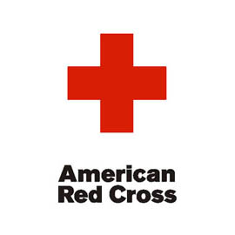
Kids Safety
Clinic
Time:

Place:

Details:


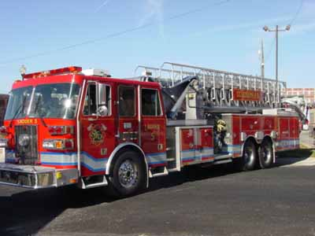

Coming Soon…
Coming Soon…
Coming Soon…
Battle of the
Excitement!
Exhilaration!
Bands


Entertainment!

Day:

Time:

Place:

Admissions:

ns:

Coming Soon…
Coming Soon…
Coming Soon…
Benefit Concert



Excitement!
Exhilaration! Entertainment!

Day:

Time:

Place:

Admissions:

Battle of the Bands
Admit One
Date:
Time:
Place:

Sponsored by your school Key Club
Battle of the Bands
Admit One
Date:
Time:
Place:

Sponsored by your school Key Club

Battle of the Bands
Admit One
Date:
Time:
Place:

Sponsored by your school Key Club
Battle of the Bands
Admit One
Date:
Time:
Place:

Sponsored by your school Key Club

Benefit Concert
Admit One
Date:
Time:
Place:

Sponsored by your school Key Club
Benefit Concert
Admit One
Date:
Time:
Place:

Sponsored by your school Key Club

Benefit Concert
Admit One
Date:
Time:
Place:

Sponsored by your school Key Club
Benefit Concert
Admit One
Date:
Time:
Place:

Sponsored by your school Key Club


Why Academics??

So you’re finally in high school, and you’re excited. You are about to enter a brand new world of new responsibilities, privileges, and choices. However, notice the last word: high school is all about choices. Making the right choices while in high school could potentially benefit you for your whole life.

An important choice you make in high school is to take your academic life seriously. Here’s why:

Academics are important to your future—it provides you with vital knowledge. Although you may not understand the point of learning about graphs in math, or writing current events in Social Studies now, sooner or later, that knowledge will become useful somewhere, sometime.

When you apply for college (and please make an effort to do so!), good academic standing will dramatically amplify your chances of getting into your college/career school of your choice. Plus, good grades garner good scholarships!

Ask yourself, why am I in high school? What am I here to do? Although it sounds cliché, remind yourself that your there to learn, to leave high school with in you than when you came. Tell yourself that life is short, and that it’s not good to waste several years of your life. If you have to go to class, you might as well as make the most of it instead of staring at the clock all day.

And last of all, no matter what adversities arise, stay in school, and it is highly recommended that you go to college. Check out the following statistics:

The median income for a person with little or no high school: $23,700.
The median income for a person with a high school diploma: $31,000.
The median income for a person with an associate degree: $37,000.
The median income for a person with a bachelor’s degree: $51,500.
The median income for a person with a graduate or professional degree: $67,200.

So you have the statistics, and you have our plead—take your academic life seriously, and you will not regret it.

Given by your school Key Club

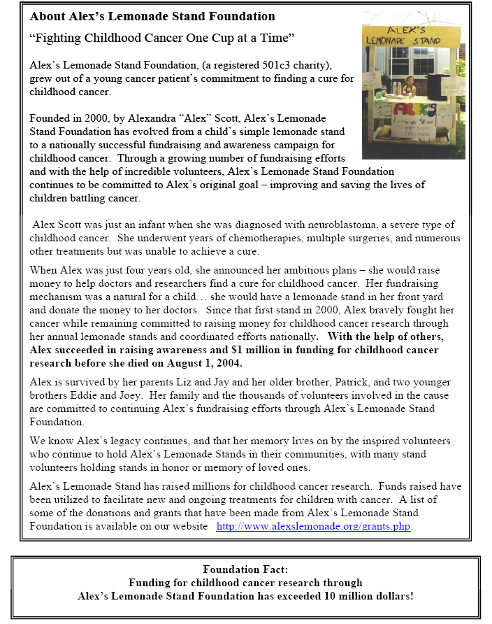

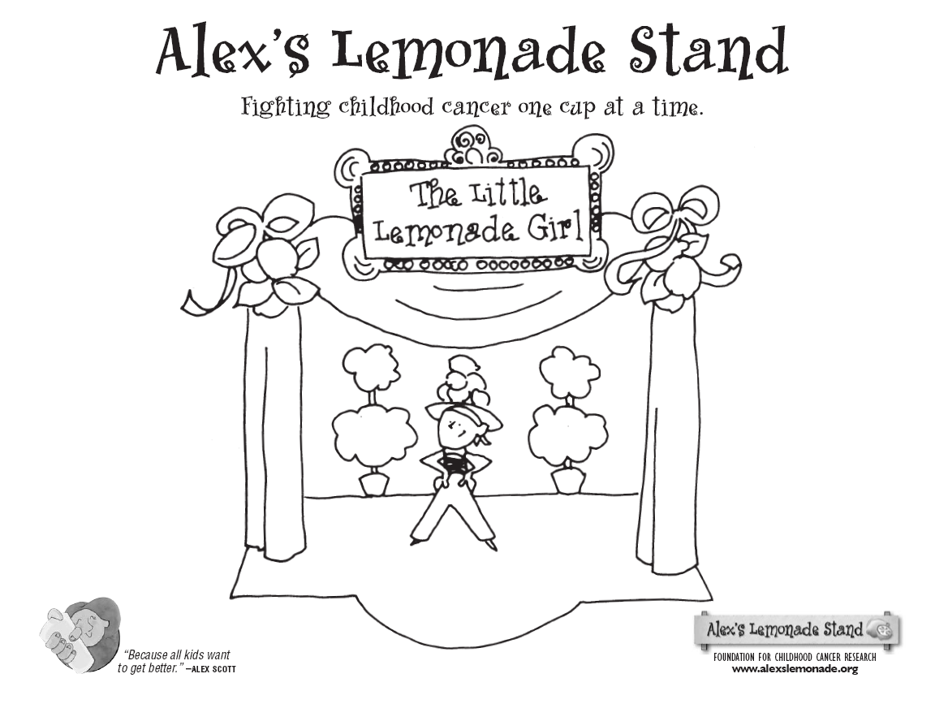
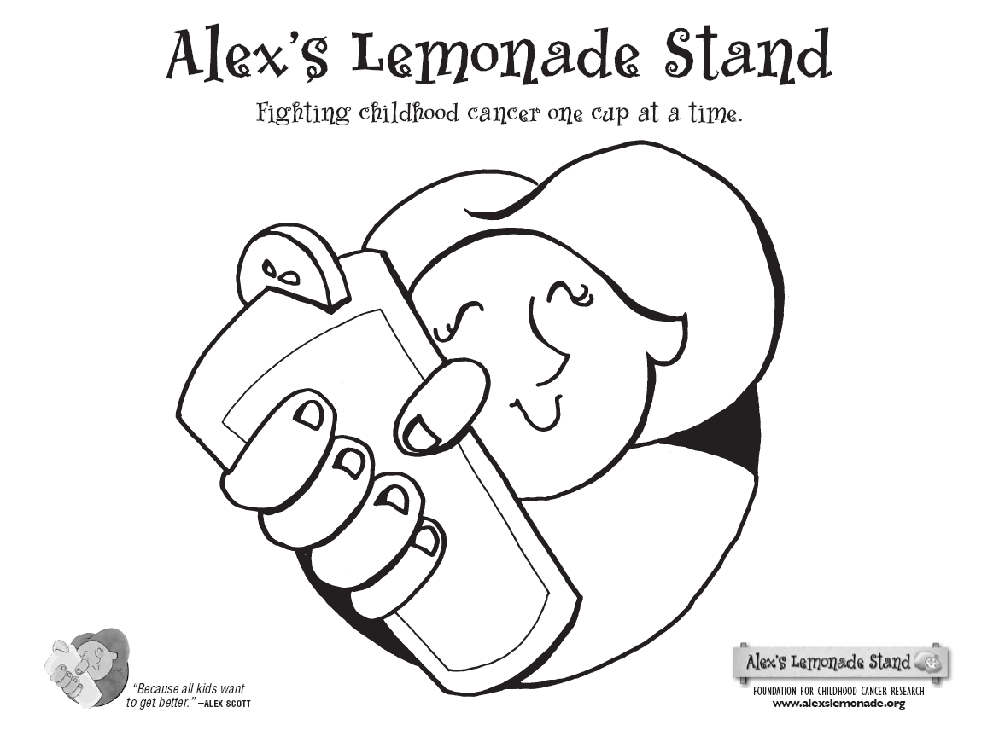





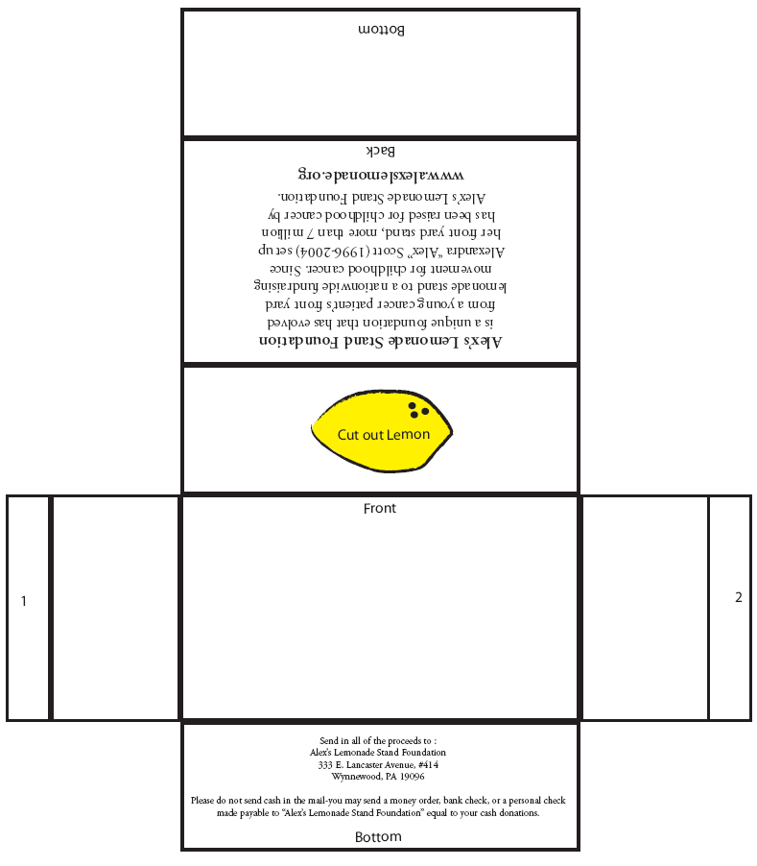

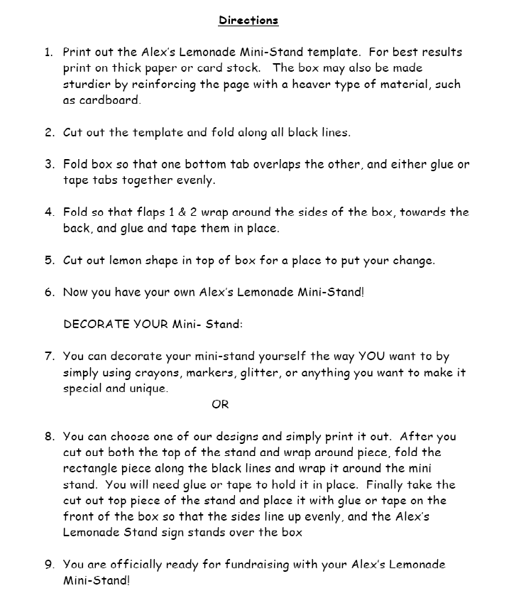



http://www.kiwanisdoll.org/make_doll.htm

Key Club Carnation/Candy Sale

For ___________ Last Hour Class____________ From_______________(may be anonymous)

_____Carnation…..$2.00 ______Bag of candy (small) …..$1.50 _____Bag of candy (large)…$2.00

Message:
Key Club Carnation/Candy Sale

For ___________ Last Hour Class____________ From_______________(may be anonymous)

_____Sucker…..$1.00 _______Bag of candy (small) …..$1.50 ______Bag of candy (large)…$2.00

Message:
Key Club Carnation/Candy Sale

For ___________ Last Hour Class____________ From_______________(may be anonymous)

_____Sucker…..$1.00 _______Bag of candy (small) …..$1.50 ______Bag of candy (large)…$2.00

Message:


Stressed? Angered? Frustrated? Take a look at these inspirational pictures and take a fresh breath out of life.

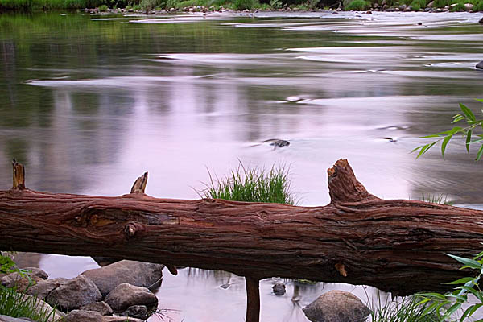







Crumble this piece of paper and squeeze it as hard as you can and throw it at the wall. Afterwards, smash it and rip it into a million little pieces.

You are Invited…

To the Key Club
No Show Ball

Front



New Dress and gown…$200
Nails and make-up…....$100
Gas mileage……………$30
Dinner before the ball…$50
Babysitter fee…………. $30
Buying an auction item
you really don’t need…$100
Not having to worry about
any of the above…...priceless

←Inside the Card
Please donate to the __________High School Key Club.
__$10 __$20 __$50 __$100
__Your choice amount_____
Your support is greatly appreciated

Please donate to help _____________. (An organization of your choosing)
__$10 __$20 __$50 __$100 __Your choice amount_____

Your support is greatly appreciated
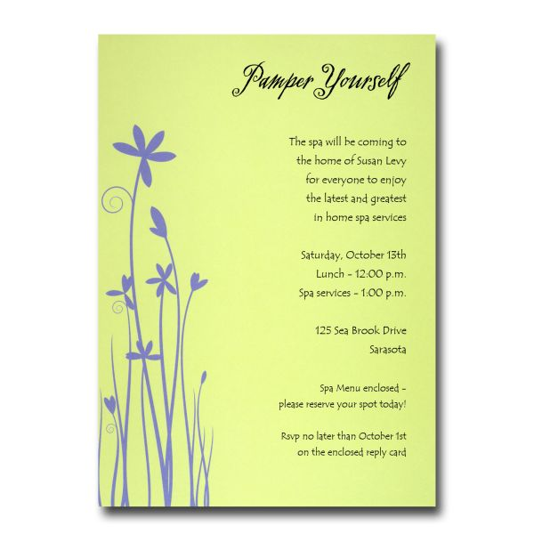
Enjoy a cup of tea in the midst of your own home with this enclosed tea bag.

Date and Time

to support the Organization or your school Key Club.

Please RVSP with the enclosed card.

We greatly thank you for your support.

Please donate to help _____________. (An organization of your choosing)
__$10 __$20 __$50 __$100 __Your choice amount_____

Your support is greatly appreciated

You’ve been Flamingoed!

Dear Lawn Owner
Congratulations! You’re lawn has been specially chosen to be flamingoed by the your high school Key Club. If you would like to have this flamingo removed and your lawn restored, you must pay a fee of to the your school Key Club.

Here are your options:
For a fee of $5………..the flamingo will be removed and your lawn restored.
For an additional fee of $5………you can place the flamingo on another’ person’s lawn of your choice
For an additional fee of $5….you can purchase insurance that guarantees that you will never be flamingoed again by your school Key Club!

Please make checks out and send to:
Your School Key Club address

WE THANK YOU FOR YOUR GENEROUS SUPPORT
IF you do not wish to donate, call ______________ and we will surely remove your flamingo at no charge.

